Peek at Our Week
Standard | Activity | Home Extension
I. PHYSICAL DEVELOPMENT  A. HEALTH AND WELLBEING  d. Feeding and Nutrition  I. A. d.1. b. Recognizes nutritious food choices and healthy eating habits | 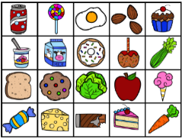  We will be sorting pretend food into categories of “Healthy/Growing Food” vs “Food that we eat for Treats Sometimes.” | Discuss which foods you eat throughout the week that are healthy “growing” foods, that are important to eat each day.

III. SOCIAL AND EMOTIONAL DEVELOPMENT  A. EMOTIONAL FUNCTIONING  1. Expresses, identifies and responds to a range of emotions  III. A. 1. a. Recognizes the emotions of peers and responds with empathy and compassion  B. MANAGING EMOTIONS  1. Demonstrates ability to self-regulate  III. B. 1. a. Recognizes and names own emotions and manages and exhibits behavioral control with or without adult support | 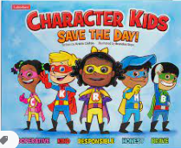 Character Kids SAVE THE DAY! [Emphasis on “Cooperative- Brandy”] |  | Sung to the tune Hokey Pokey:  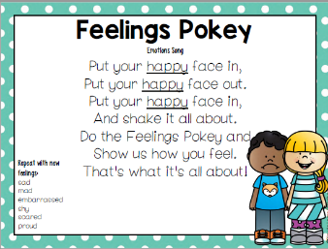
FAITH FORMATION  Develops a sense of awe and wonder, respect, gratitude and stewardship for God’s creation.  VI. SCIENTIFIC INQUIRY  D. EARTH AND SPACE SCIENCE  VI. D. 1. c. Begins to explore and discuss simple observations of characteristics and movements of the clouds, sun, moon and stars |  | 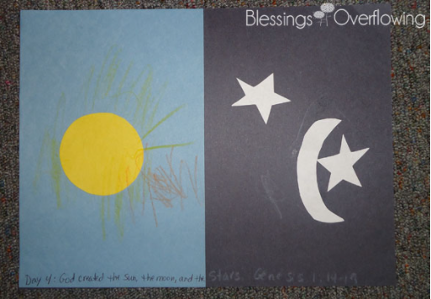  God created the sun, moon, and stars. Genesis 1:14-19  We will discuss the sun, moon, and stars:  -our sun is a star  -we see the sun during the day  -we can see other stars and the moon at night  -sometimes we can see the moon during the day also | Florida Office of Early Learning:  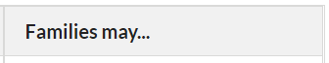  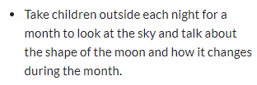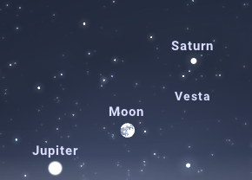  During the month of September, the Full Moon will be visible in the evening eastern sky Friday, September 9th (if there are no clouds). The planet Saturn will above and slightly to the right and Jupiter will be just below the moon near the horizon.

