Standards | Activities | Home Extension
VIII. Creative expression through the arts  A. Sensory art experience  1. Combines with intention a variety of open-ended, process-oriented, and diverse art materials  I. Physical Development  C. Fine motor development  1. Demonstrates increasing precision, strength, coordination, and efficiency when using hand muscles for play and functional tasks. | Jackson Pollak paintings  (Need a shoebox, a marble, spoons, egg carton)  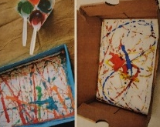  Splatter painting is an easy and expressive way to create abstract art.  Organizing art center by color.  Allow children to work on their fine motor skills as they pick up and place materials into their chosen categories/piles.  As they arrange materials, they are working on sorting and categorizing.  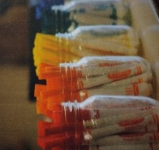 | Begin collecting different colored objects with your child. Each week we will be exploring a different color. The items will need to be small, as they are going inside a mason jar along with other students’ finds.  Colors help us see the differences in the space around us.  Explain how we add color to our homes and to our classrooms by using different colored paints, and not always plain white.

The week’s color is YELLOW

