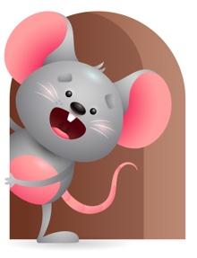
Peek at Our Week

Standard Focus | Activity | Home Extension Activity
Language and Literacy- Younger- Begins orienting to own name and enjoys playful word games like peek-a-boo. Older- Begins to demonstrate and respond to adult speech with coos and babble. | Younger- Play a game like peek-a-boo using their name and saying peek-a-boo I see a yellow ball, yellow truck, yellow cup. Older- Read the book- Five little ducks. See how many yellow toys you can name that you see in the room. | Younger- continue to play games with them using their name. Examples- pat-a-cake, peek-a-boo, where is (use child’s name ) I don’t know -I don’t know-we must go and find them- we must go and find them -where are they? Where are they? You can make up your own words too. Older- Read books and name the things you see in them and the color they are.
Mathematical Thinking- Younger- Explores objects in various ways. Older- Observes songs and finger plays that involve numbers . | Younger- introduce stacking blocks and tell them what color they are as you count to 3 and drop them in a bucket. Older- Do finger play 5 green and speckled frogs and sing Down on Grandpa’s Farm there is a little yellow duck, and five little ducks went out one day, and you are my sunshine. | Younger- Introduce things you might have at home and tell them what it is and the color of it-this helps them to hear names and colors of things. Older- Do some songs or finger plays you might know that involves numbers. Examples- 5 little ducks went out one day, This old man he played 1.
Scientific Inquiry-Younger & Older -Uses senses to explore and understand their physical environment. | Younger- Let them explore their senses. Give them rattles to shake and toys that make noise-Mouthing-let them see how cold a teether feels in their mouth and how good it feels to just chew on it. Dropping -let them drop different colored objects in a bowl. Older- let them smell empty spice jars and taste different colors of food. Touch textured materials. | Younger& Older- Continue to let them explore their environment. Show them bright things around the house and let them explore. Read books that have bright colors and help them to put their toys in groups of colors. All the red toys, blue toys, green toys, yellow toys.

Parent Resources

Other News- We will focus on yellow this week.

