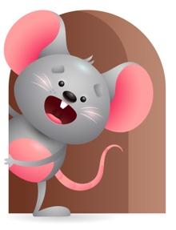
Peek at Our Week

Standard Focus | Activity | Home Extension Activity
Approaches to Learning-Younger & Older Creativity and Inventiveness- Shows interest in familiar objects and people. | Younger- Stack up the blocks and tell them the color it is and knock them down. Roll balls back and fourth to each other and push the cars across the floor. Older- play with the balls and tell them what color they have. | Younger & Older- Continue to help introduce them to colors- tell them the colors of their food, toys, colors you see outside, colors of the things you see in a book.
Social Studies- Younger & Older- Time, Continuity, and Change- begins to respond to time, Routines and schedules. | Younger & Older- Interact with them throughout the day- talk or sing to them while diapering, read colorful books to them and talk about what you see, let them practice feeding self and holding their bottles, pat their backs at nap or rock them to sleep. | Younger & Older- Try to do things at the same time each day. ( wake up, eat, play , go to school, lunch, nap, bath, bed time). They will soon catch on that this is your everyday routine.
Language and Literacy-Younger- Begins to look at familiar people, objects, or animals when they are named. Older- Conversation- responds to adult speech with coos and babbling. | Younger- Read the books- The big hungry Bear, Color Zoo, Put me in the zoo. Tell them the name of each animal. Older-Read the same books only Talk about the animals and what color are they and what sound do they make? Try to encourage them to respond to your talking by cooing or babbling. | Younger & Older- Read, Read, Read- Talk about and name all the things you see in the books you read. Talk about the color of objects and animals, the sounds they make, what are they doing in the book- ( sleeping, eating, playing, going for a walk) encourage them to make sounds and coo and babble. Helps their vocabulary.

Parent Resources

Other News-

