Peek at Our Week
Standard Focus | Activity | Home Extension Activity
- Demonstrates directionality, order and position of objects by following simple directions  - Responds to and expresses opinions and feelings about own art form as well as a variety of artistic expressions of others | Jackson Pollock  The children will splatter and spray paint on a large painter’s drop cloth outside  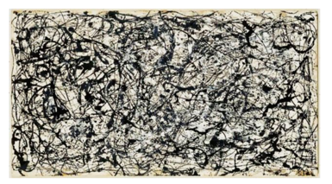 | Painting like Jackson Pollock is fun but can also be very messy. Here’s a relatively neat way to achieve the same look: painting with yarn! Cut any color yarn into 6 inch pieces, one for each color of paint you intend on using. Put the paint onto paper plates and put a piece of yarn into each color. Either using your fingers or a clothes pin pick up the yarn and drag or stamp in on the paper.  Watch this video to see it done: Yarn Painting (https://www.youtube.com/watch?v=_iHFLUwh43M)
- Makes simple predictions and reflects on what caused something to happen  - Participates in and discusses simple experiments  - Responds to and expresses opinions and feelings about own art form as well as a variety of artistic expressions of others | Color Clip Cards:  Children indicate the matching color using a clothes pin. | Clothes pins are a great tool for exercising the muscles used for fine motor skills. Give your child some clothes pins and craft sticks and watch what they can build. Your child can march color using colored clothes pins and colored craft sticks. If you can’t find any to purchase, just color plain ones with either crayons or markers.
- Begins to recognize nutritious food choices and healthy eating habits | “Eat the Rainbow” Party | 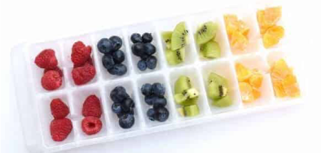  A fun way to do this at home is to use an ice cube tray. Fill each hole with different colored foods for a “Rainbow Snack!”
Parent Resources: The color we will be learn about is Purple. Tuesday, Valentine’s Day, we will be celebrating with an “Eat the Rainbow Party”.

