Peek at Our Week
Standard Focus | Activity | Home Extension Activity
- Demonstrates directionality, order and position of objects by following simple directions  - Uses size words to label objects | Piet Mondrian  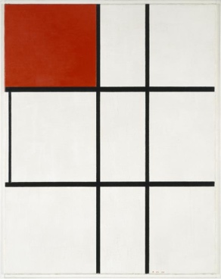  The children will be given a piece of paper with black lines printed on it. They will paint some of the squares red. | This style of art can be created using strips of black paper and primary color squares and rectangles. Help your child cut out these shapes and then glue them onto another sheet of paper.  If you have not introduced your child to scissors, now is the time. Here are some fun tips and hacks to help your little ones practice their scissor skills:  - Start with “snipping”. Practicing small snips will help promote practice, as well as success!  - Teaching “thumbs up” when holding the scissors by placing a small sticker or Washi tape to remind them which side is up – tell them to make sure they can see their sticker.  When teaching the forward motion aspect, make it fun! Pretend like the scissors are alligators, trains, cars, etc. and have them cut across a path or road.
- Participates in group sorting and data collection | Sort buttons into color coded buckets | 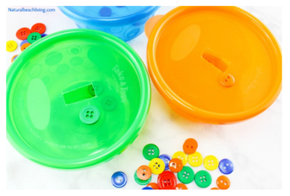  Here’s another site to check out for a fun button sorting activity. Natural Beach Living
- Participates in group sorting and data collection  - Increasingly coordinates hand and eye movements to perform a variety of actions with increasing precision | String red, blue and yellow beads onto corresponding color pipe cleaners | Try this fun stringing activity, stringing Cheerios or Fruit Loop cereals onto a pipe cleaner or string.
Parent Resources: Red is the color for the week.

