Peek at Our Week
Standard Focus | Activity | Home Extension Activity
- Represents ideas and observations through drawings or using other forms of representation (e.g., manipulatives or different objects) | Blue – Monet  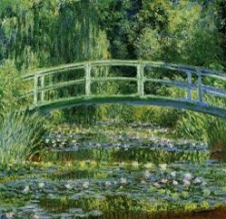  The children will be fingerpainting on a small canvas using shades of blue and green. | Fingerpainting does not need to be messy. Try using finger paint designed for the bathtub. 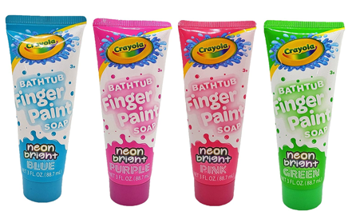
- Participates in group sorting and data collection  - Describes what objects are used for and is able to express ideas (e.g., names some colors, shapes, and says full name) | Color Hunt:  The children will pick a card out of a box and then find an object in the classroom which makes the color on the card. | The color hunt game can be played at home. A great time to do it is at clean-up time. Ask your child to put away the blue items and then the red ones and so on until the room is clean..
- Describes what objects are used for and is able to express ideas (e.g., names some colors, shapes, and says full name)  - Begins to demonstrate knowledge of verbal conversational rules (e.g., appropriately takes turns, does not interrupt, uses appropriate verbal expressions and uses appropriate intonation) | Roll and cover Color Game  The child rolls the die and then matches the number to the color on the key. Then they cover that many of the colored obejcts on the game board. | Three is the perfect age to start playing simple games with your child. Games such as “Hi Ho Cherry-O”, “Go Fish”, and “Candy Land” are just a few examples. Playing these types of games teaches your child how to take turns and be patient, how to remember and follow the rules and how to accept losing. Don’t wait! Start now playing organized games with your child.
Parent Resources: The color for this week is blue.

