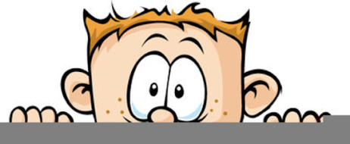

Peek at Our Week
Standard Focus | Activity | Home Extension Activity
- Responds to and expresses opinions and feelings about own art form as well as a variety of artistic expressions of others | 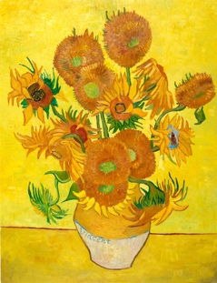  Van Gogh’s Sunflowers  The children will be using flowers as stamps to recreate this famous painting. | Take a trip to a florist or floral department of the grocery store, Hobby Lobby or even Dollar Tree and look at all the colors, textures and shapes of the flowers. Maybe allow your child to buy one of their favorite flowers to bring home.
- Increasingly coordinates hand and eye movements to perform a variety of actions with increasing precision  - Uses hand-eye coordination to manipulate objects and materials (e.g., completing large-piece puzzles or threading beads with large holes, begins to use scissors) | Wooden food will be replaced by colored pompoms to promote the use of imagination and descriptive language when pretending to cook. Small containers with different closures will be added to strengthen hand muscles and give an opportunity to practice opening lunch containers. | It is easier and neater to teach your child how to open and close containers when they are empty. So, if your child enjoys pretending to cook, give them a few of the containers you use to pack their lunch and some pompom or dry pasta and let them cook up a storm.
- Increasingly coordinates hand and eye movements to perform a variety of actions with increasing precision  - Sustains attention for brief periods and finds help when needed | Rainbow colored ribbons sensory bin with beads and tubes. | Assembling a sensory bin can be easy. Just gather some small objects, such as pasta, rice, pompoms, etc. next add plastic spoons, cups, small lunch containers, cars, people, and animals. Then sit back and watch them explore!
Parent Resources: The color of the week is yellow.

