Standards | Activities | Home Extension
VI. Scientific Inquiry  A. Scientific exploration through exploration and discovery  3. Uses understanding of casual relationships to act on social and physical environments  VI. Scientific Inquiry  A. Scientific Inquiry through exploration and discovery  3. Uses understanding of casual relationships to act on social and physical environments  Benchmark d. Shares findings and outcomes of experiment | Have students gather fallen leaves if possible (not brown because they will crumble)  Demonstrate how to do a leaf rubbing.  A rubbing is done by placing a leaf under a sheet of paper and rubbing crayon over top of it, to reveal its texture and shape.  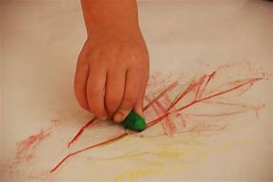  Wassily Kandinsky  Concentric Circles  See if children can recreate this piece of art using only crayons.  (Need: wax paper, liquid starch, paint brushes, colored tissue paper cut into squares) | Please bring in a variety of different leaves so we can explore leaf rubbing from multiple environments outside of our school.  Watch the sunset this week with your child and have them tell you all of the colors they see. Bring in pictures to shar with the class if you desire 😊

This week’s color is ORANGE

