Standards | Activities | Home Extension
VIII. Creative expression through the arts  A. Sensory art experience  1. Combines with intention a variety of open-ended, process-oriented, and diverse art materials  I. Physical Development  d. Food and nutrition  1. Responds to feeding or feeds self with increasing efficiency and demonstrates increasing interest in eating habits and making food choices  Benchmark a. Assists adults in preparing simple foods to serve to self or others | Card marbling.  (Half a piece of cardstock per child. Put shaving cream in a shallow pan and then allow students to dropper in pink and purple color. Student can mix up/swirl the colors together. Place the cardstock onto the shaving cream. Wipe off excess and hang to dry.)  Discuss what color foods do kids notice while eating?  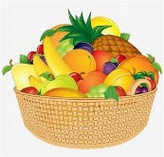 | Fill balloons with paint and throw them at the desired canvas.  Explore with your child. Does the paint mix?  Make Valentine’s Day cards at home with your child for a family Valentine.

This week’s color is PURPLE

