Standards | Activities | Home Extension
VIII.Creative expression through the arts  A. Sensory art experience  1. Combines with intention a variety of open-ended, process-oriented and diverse art materials.  I. Physical Development  C. Fine motor development  1. Demonstrates increasing precision, strength, coordination, and efficiency when using hand muscles for play and functional tasks. | When outside, have kids collect green things they find. When we come back inside, ask the children to share their findings so that we may see all of the different shades of green they could find.  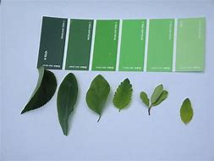  Allow kids to paint with grass, leaves, and flowers today.  Claude Monet Water Lilies Art  Use a paper plate, paint, and cupcake liners.  Finger painting.  The lily pads are made of pink and green cupcake liners. Glue them to the finger-painted canvas. | Take a trip to the paint store and get some paint samples. Ask your child to find objects matching the colors you selected and bring in a picture of this to share with the class.  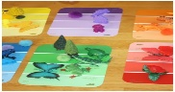  Make homemade playdough.  Get different colored chalks, and let children crush them up inside the playdough to create new colors.

This week’s color is GREEN

