Standards | Activities | Home Extension
IV. Language and Literacy  G. Emergent writing  1. Begins to show motivation to engage in written expression and appropriate knowledge of forms and functions of written composition  Benchmark b. Uses letter-like shapes or letters to write words or parts of words  V. Mathematical Thinking  C. Patterns  3. Recognizes the unit of repeat of a more complex pattern and extends the pattern (ABB or ABC) | Symmetrical word art using child’s name.  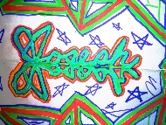  Piet Mondrian inspired artwork  Using white construction paper as canvas, teach students to paint black lines both horizontally and vertically across their paper.  Once finished with that portion of the artwork, there should be squares and rectangles of different size that can be filled in with red, yellow and blue in various spaces, while still leaving some spaces white.  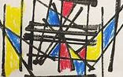 | Throughout this unit, each child will be making a color wheel in class to take home once finished. I spy is a great color game to play together.  Work with your child on patterning this week.

This week’s color is RED

