Peek at Our Week
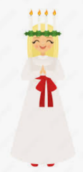  Standard Focus | Activity | Home Extension Activity
IV. LANGUAGE AND LITERACY  F. EMERGENT READING  3. Shows alphabetic and print knowledge  IV. F. 3. b. Recognizes almost all letters when named (e.g., when shown a group of letters, can accurately identify, verbally or nonverbally, the letter that is named) | 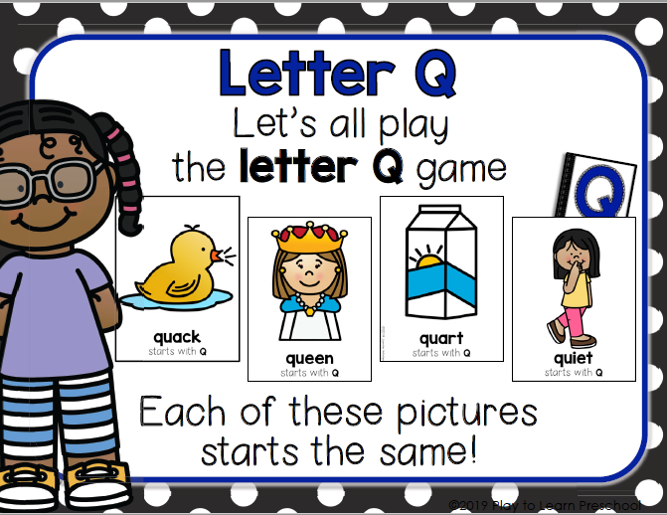  Our letter this week is "Qq" | 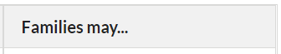  - Read alphabet books with children.
A. CULTURE  VII. A. 2. Understands everyone belongs to a culture | Saint Lucia’s feast day is December 13t^{h}, this Tuesday. We will learn a little about St. Lucia celebrations in Scandinavian countries. We will discuss how the children dress for this celebration and listen to one of the songs they sing. | - Introduce children to foods from other countries and talk about how they are different than the foods their families eat.
V. MATHEMATICAL THINKING  A. NUMBER SENSE  V. A. 5. Constructs and counts sets of objects (one to 10 and beyond) | 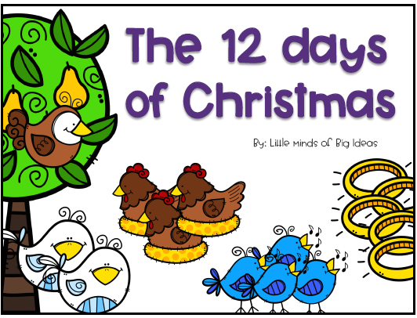 and 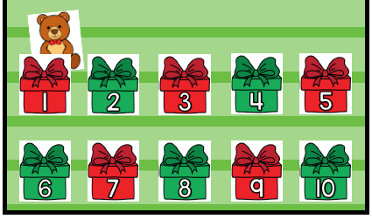  Reading and singing about the 12 days of Christmas, and looking under 10 “presents” to see what’s there. Both activities use ordinal numbers. | - Ask for children’s help in distributing items like snacks, or in laying napkins out on the dinner table (e.g., one napkin per plate).
FAITH FORMATION- Asks for and listens to Bible stories. | For Advent, in our class, we are hanging Bible Story ornaments on our Jesse (Christmas) tree. This week’s stories are: Zechariah and Elizabeth, John the Baptist, Mary and Angel Gabriel, Joseph, Stepfather of Jesus, Joseph and Mary Arrive in Bethlehem, Angels Proclaim the birth of Jesus, Shepherds, and Birth of Christ | Please return to Sacred Heart this Friday, December 16th , at 3:00 p.m. for our school wide Christmas Program. Bring chairs for sitting if you would prefer a guaranteed seat. Your children will have parts in the program and will be singing Christmas songs.

Parent Resources:
Other News: Our school wide Christmas Program will be this Friday, December 16th at 3:00 p.m. in Roxine’s Butterfly Garden, just outside the VPK classrooms.
We hope you have a blessed and wonderful Christmas season with your family and friends!

