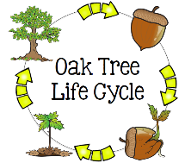
Peek at Our Week
Standard Focus | Activity | Home Extension Activity
IV. LANGUAGE AND LITERACY  F. EMERGENT READING  3. Shows alphabetic and print knowledge  IV. F. 3. a. Recognizes that print conveys meaning  2. Shows age-appropriate phonological awareness  IV. F. 2. d. Combines syllables into words (e.g., “sis” + “ter” = “sister”) | 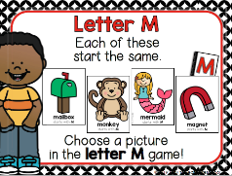  Our letter this week is "Mm"  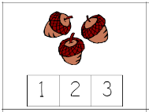  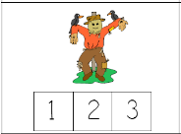  Counting  Syllables  In Fall Words | 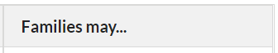  - Collect some small household items (pencil, block, cookie, toothpaste, cup, etc.) or pictures and place them in a box or small bag. The adult removes one item, says its name and asks children how many “claps” it has. Say the object name again, clapping as the adult says each syllable. Then it is the children’s turn to take an item out of the box, say the name and clap the syllables.
A. SCIENTIFIC INQUIRY  B. LIFE SCIENCE  1. Demonstrates knowledge related to living things  VI. B. 1. b. Notices the similarities and differences among various living things | 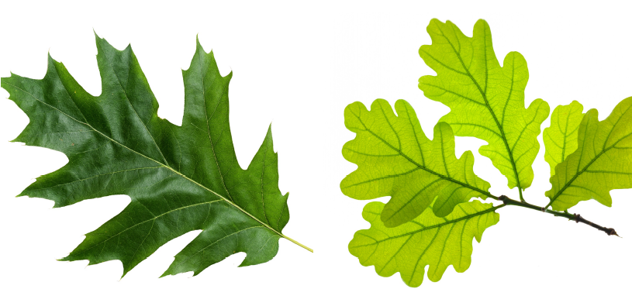  Oak leaves Maple leaves | - Give children two different kinds flowers (or leaves) and ask them to tell how they are alike and different.
V. MATHEMATICAL THINKING  A. NUMBER SENSE  V. A. 2. Counts and identifies the number sequence “1 to 31” | 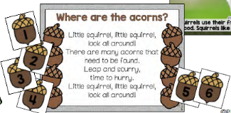  Finding numbered “acorns” and then placing them in numerical order. | - Play number games with children by rolling dice or use a number card, move that many spaces.
STANDARD 2- SPIRITUAL DEVELOPMENT  SESD:2a an appreciation of God’s goodness and personal love for them | David and Goliath 1 Samuel 17  Jonah and the Whale Jonah 1-4 | Taken from My Catholic Life: Daily Reflections *****  “It seems clear that one of the main lessons from Jonah’s life was that God is relentless in His love for us and is relentless in calling us to embrace His will. So, Jonah’s life and actions become prophetic and teach us a great lesson.”

Parent Resources: ***** https://catholic-daily-reflections.com/2018/01/20/jonah-man-ran-god/
Other News: Our class needs snacks for November. Favorites include Veggie Straws, Goldfish, Animal Crackers, Scooby Snacks, & Pirate’s Booty.
Open House and our Thanksgiving Luncheon will be on Friday, November 18th from 11:00 a.m. to 12:30 p.m. Also, thank you for your donations for “Share the Bounty” (Sacred Heart prepares Thanksgiving Dinner Baskets for 12 families), Our class is being asked to donate dessert items such as non-perishable box/canned desserts mixes, and frostings. We will be collecting donations until Fri., 11/18.

