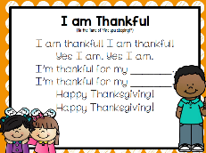
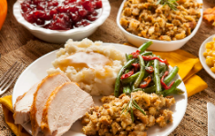
Peek at Our Week
Standard Focus | Activity | Home Extension Activity
IV. LANGUAGE AND LITERACY  F. EMERGENT READING  2. Shows age-appropriate phonological awareness-Listens and matches rhythm, volume and pitch of rhymes, songs and chants  3. Shows alphabetic and print knowledge  IV. F. 3. a. Recognizes that print conveys meaning | 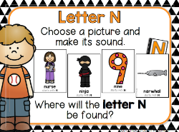  Our letter this week is Nn”  Pumpkin Pie  Rhyming | Florida Office of Early Learning:  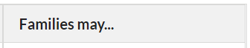  - As you read and reread books that rhyme, encourage your child to finish rhyming lines in the books read aloud.
VII. SOCIAL STUDIES  G. ECONOMICS AND RESOURCES  VII. G. 1. Recognizes the difference between wants and needs | 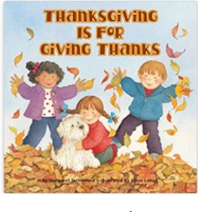 | - Acknowledge children’s requests for things that are not a current need or priority such as (e.g., “I know you really want to go to the park, but we do not have time to stop right now because we need to go to the grocery story.” or “I can see you really want to buy that book. Let’s go to the library next week and see if we can borrow it instead of buying it.”).
V. MATHEMATICAL THINKING  D. GEOMETRY  V. D. 3. Creates two-dimensional shapes using other shapes (e.g., putting two squares together to make a rectangle) | 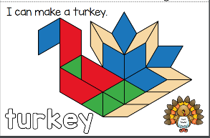 | - Cut a cereal box into different shapes. Children can put them together in different ways to make different things, or sort shapes by how many sides they have.
FAITH FORMATION  Faith Development Concepts  Knows that God loves, protects and provides for them.  Recognizes that prayer is talking to God. | Daniel and the Lions’ Den  Daniel 6  Queen Esther [the sin of Haman)  Esther 1-9 | If you want to watch a 30-minute story about Queen Esther with your child, the “Veggie Tales-Esther: The Girl Who Became Queen,” is a nice show that emphasizes the power of God, instructing us to use the blessings given by God to help others.  https://www.youtube.com/embed/sy_an0WkaLQ

Other News: This Friday, November 18th is our Sacred Heart ECC Luncheon, from 11:00 to 12:30. The younger classes will be served first. VPK classes will be served about 11:40ish. If you need to return to work sooner, you and your child may go through the line earlier.
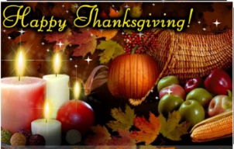
You may come into our class starting at 11:00 a.m., and we will have a short presentation for you before lunch. After you have gone through the line to get lunch plates for you and your child, you will be able to sit anywhere, outside or in our classroom. You do not need to bring any food; this luncheon is being prepared for the kids and for you.

We hope you have a blessed and wonderful Thanksgiving celebration with your family next week!

