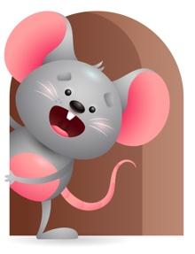
Peek at Our Week

Standard Focus | Activity | Home Extension Activity
Social and Emotional-Younger- Notices peers by looking, touching, or making sounds. Older- Experiences and develops secure relationship with a primary caregiver. | Younger- While looking, touching and making sounds they will interact with caregiver. Older- While listening to caregiver sing a song you can ask a few questions like. Does this make you want to move? Drop a block. Was that loud? | Younger- While playing you can help them to notice what you and other things around them do by looking, touching, and making sounds. Older- While reading or singing a song you can make sounds and ask if they can make the same sound.
Creative Expression-Younger- Uses movement to show increasing body awareness in response to own environment. Older- Responds spontaneously to different forms of art in the environment. | Younger-We will practice rolling from our back to stomach and trying to sit up. Older- We will tear paper and roll up paper balls. | Younger- Practice helping your child move his body. Exercise their legs for them and help them to walk by holding their hands. Older- Let them paint with brushes and do some finger painting.
Scientific Inquiry-Younger- Responds to information received through the senses. Older- Demonstrates knowledge related to living things and their environment. | Younger- We will set up play time, so they have lots to explore. Older- Read Old McDonald had a farm and talk about the animals and what they eat? Where they live? | Younger- Give them objects they can mouth, touch, shake, taste. Older – Talk to them about pets you or your family members have. Tell them what kind of pet it is and where it lives. What does it eat and drink?

Parent Resources

Other News-

