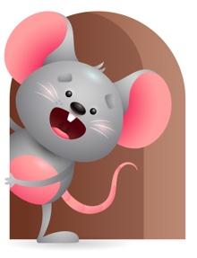
Peek at Our Week

Standard Focus | Activity | Home Extension Activity
Mathematical Thinking-Younger- Explores and experiments with objects in the environment. Older- Notices shapes in the environment. | Younger- We will explore objects in the environment to see what they do. Older- We will introduce shape sorter and show them the different shapes and how they fit in the bucket. | Younger- Let them explore different toys in your home. Show them how they work and what you can do with them. Older- Show them different shapes in your home. (Bowl is round, book is square.)
Physical Development-Younger- Begins to use hands for play and functional tasks. Older- Demonstrates increasing strength, coordination, and using hand muscles. | Younger- We will practice holding our bottles and grasping for toys. Older- We will practice using eye-hand coordination to stack blocks and push cars. | Younger- Continue to practice letting them hold their bottles during feeding. Older- Let them practice stacking things. (Blocks, cups)
Language and Literacy-Younger- Turns head to familiar sounds. Older- Responds to repeated words and phrases. | Younger- Listens and reacts to the sounds you make by looking and turning their head towards it. Older-Read the book -I Love all of me- Repeat the words so they will start to respond. | Younger- Play and make different sounds for them to hear and respond to. Older- Read to them throughout the day and repeat the words and phrases. They learn through repetition.

Parent Resources

Other News-

