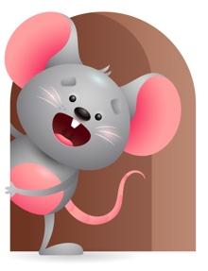
Peek at Our Week

Standard Focus | Activity | Home Extension Activity
Social Emotional- Younger- Building and Maintaining Relationships with Adults and Peers. Older- Develops positive relationships with peers. | Younger- Give some one on one- Sing and rock them as you feed them their bottle. Older- While interacting with them ask questions throughout the day- Are you tired? Hungry? Was that loud? | Younger- Continue to build on relationships- Help them eat, rock them to sleep, read a book together. Older- Spend time asking questions during the day to develop those positive relationships.
Approaches to Learning- Younger- Shows interest in the environment. Older- Shows interest in people and objects. | Younger- play with musical toys and listen to the different sounds they make. Older- Play with the community helpers(people). Talk about what each one does. | Younger- Give them things to play with that interest them- pots and pans, bowls, cups, light up toys. Older- Give them objects they have to use their senses to see how they work- knobs to turn, buttons to push.
Mathematical Thinking- Younger- Explores objects and watches what they do. Older- Explores objects in hands. | Younger- Play with rattles and shake them to hear the sound they make, push buttons on pop up toy and watch what it does. Older- Let them explore objects and count as they drop them in a bucket. | Younger- Give them a ball and let them watch as you roll it, throw it in the air and catch it, and bounce it. Older- Give them objects they can explore with their hands- bowl, spoon, cup, finger foods.

Parent Resources

Other News- Thanksgiving Luncheon

