STANDARD | ACTIVITY | HOME EXTENSION
VI. Scientific Inquiry A. SCIENTIFIC INQUIRY THROUGH EXPLORATION AND DISCOVERY 1. Uses senses to explore and understand their social and physical environment Benchmark a. Begins to identify each of the five senses and how they relate to the sense organs Benchmark b. Uses senses to observe and experience objects and environment | This week we will talk about how owls can see very far, even in the dark. We will turn out the lights in the classroom and have the children stand in circle, and someone will stand on the other side of the room and hold up tiny objects and let them see if they can see like an owl. | Take your child outside one evening, and play I Spy. See what can be seen in the dark and how far.  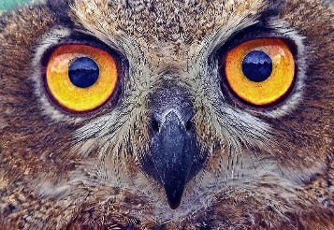
VI. Scientific Inquiry A. SCIENTIFIC INQUIRY THROUGH EXPLORATION AND DISCOVERY 1. Uses senses to explore and understand their social and physical environment Benchmark a. Begins to identify each of the five senses and how they relate to the sense organs Benchmark b. Uses senses to observe and experience objects and environment | In small groups, we will talk about different disabilities that some people may have with their sight and how other senses can be enhanced when we lose a sense. Then the children will get to explore a brail book. | While at home blind fold your child, and hand them some familiar objects from around the house and see if they can guess what they are.  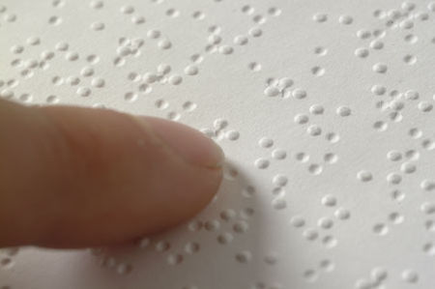
Faith Formation- Sin and Consequences  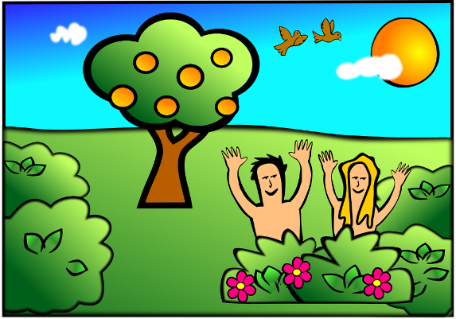 | This week, we will read the story about Adam and Eve, and talk about how they sinned, and how they had consequences for their sin. We will then hide apples and fake snakes outside and give them instructions to find only ONE, if they come back with more, use that as a learning opportunity to explain that if they don’t listen, it is considered a sin. | Talk with your child at home about how different behaviors at home could be considered a sin, and what the consequences for those behaviors may be.

