STANDARD | ACTIVITY | HOME EXTENSION
VI. Scientific Inquiry A. SCIENTIFIC INQUIRY THROUGH EXPLORATION AND DISCOVERY 1. Uses senses to explore and understand their social and physical environment Benchmark a. Begins to identify each of the five senses and how they relate to the sense organs Benchmark b. Uses senses to observe and experience objects and environment | At morning circle we are going to read the book Pumkin Jack, then the class will clean out and carve a pumpkin and place in a large container with a lid to allow the children to watch the rotting process for the next few weeks | It is Fall! Carve your own pumpkins at home, encourage your child and family to use their senses through the carving process. How does it feel, what do you see, can you hear it squish, how does the pulp taste, how does it smell?  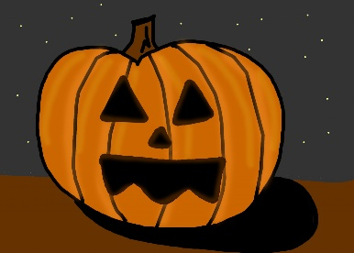
VI. Scientific Inquiry A. SCIENTIFIC INQUIRY THROUGH EXPLORATION AND DISCOVERY 1. Uses senses to explore and understand their social and physical environment Benchmark a. Begins to identify each of the five senses and how they relate to the sense organs Benchmark b. Uses senses to observe and experience objects and environment | 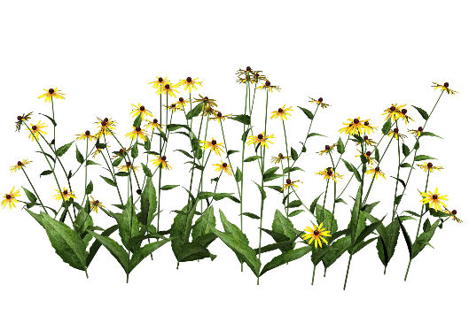  This week we are going to play “I Spy” outside in the Butterfly Garden, encouraging the children to use their sense of sight. | Take a hike or a walk with your family and play “I SPY” What can they see, hear, smell and feel while on the walk.
Skill Streaming- Problem Solving | How to Solve a Problem. One day at morning circle this week we will read the book “Splat the Cat, and the Pumpkin Picking Plan” then we will discuss how we can identify what a problem is and ways we can solve problems. At afternoon centers in small groups we will create a scenario using several props (animal counters, blue felt and blocks) and let the children explore how to get the animals to cross the water. | The next time you or child encounter a problem, point it out, help them identify the problem and encourage them to figure out how the problem can be solved.  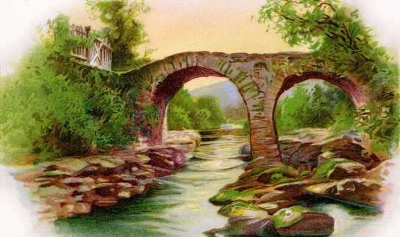  This Photo by Unknown Author is licensed under CC BY-NC-ND

