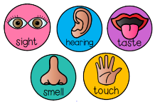
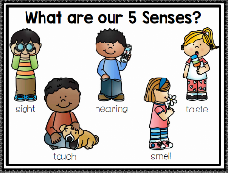
Peek at Our Week
Standard Focus | Activity | Home Extension Activity
IV. LANGUAGE AND LITERACY  F. EMERGENT READING  3. Shows alphabetic and print knowledge  IV. F. 3. a. Recognizes that print conveys meaning | 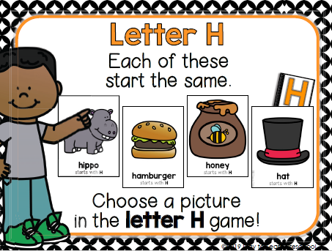  Our letter this week is "Hh" | 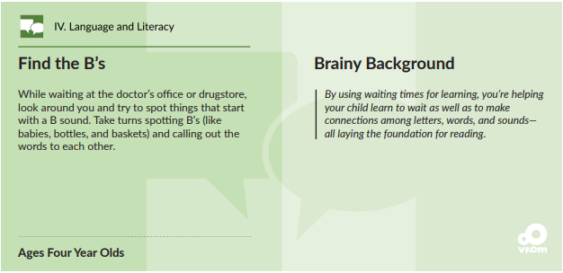  Find the H’s
A. SCIENTIFIC INQUIRY  1. Uses senses to explore and understand their social and physical environment  VI. A. 1. a. Identifies each of the five senses and the relationship to each of the sense organs | 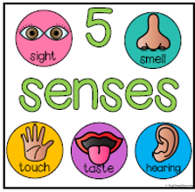 | 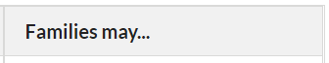  Florida Office of Early Learning:  Provide opportunities to use sense of touch to experience how things feel (warm, cold).
V. MATHEMATICAL THINKING  A. NUMBER SENSE  V. A. 7. Reads and writes some numerals one to 10 using appropriate activities | 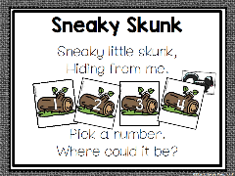  Numeral Recognition (which number (1-20) is the skunk hiding behind?) | Write some numbers on paper (0-10) and ask your child if they can count and show the same number of fingers on their hands.
FAITH FORMATION  Faith Development Concepts  SAFE ENVIRONMENT STANDARDS  Standard 1 -Cognitive Development  SECD:1d There are “good’ and “bad” choices | Adam and Eve being cast from the Garden of Eden Genesis 2-3  Noah’s Ark Genesis 6-9  Sodom and Gomorra Genesis 19 | Read and discuss these Old Testament stories using a children’s picture bible.

Parent Resources:
Other News: This week we begin a new unit. We will explore many aspects of fall as we learn about our 5 senses.

