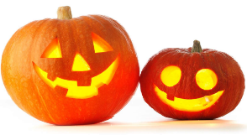
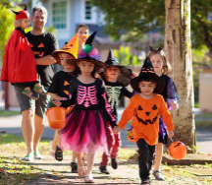
Peek at Our Week
Standard Focus | Activity | Home Extension Activity
IV. LANGUAGE AND LITERACY  F. EMERGENT READING  3. Shows alphabetic and print knowledge  IV. F. 3. c. Names letters (e.g., when shown an uppercase or lowercase letter, can accurately say its name)  2. Shows age-appropriate phonological awareness  IV. F. 2. a. Distinguishes individual words within spoken phrases or sentences | 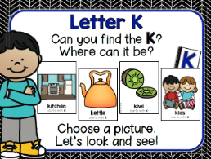  Our letter this week is "Kk”  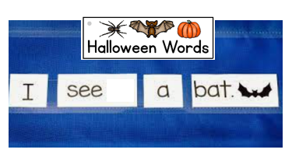 | Florida Office of Early Learning:  - Play with children by clapping, tapping, jumping or stomping one time for each syllable in a word, or individual words within spoken phrases or sentences
A. SCIENTIFIC INQUIRY  B. LIFE SCIENCE  1. Demonstrates knowledge related to living things  VI. B. 1. c. Understands that all living things grow, change and go through life cycles  These last 3 weeks we have been discussing animal and plant lifecycles. | 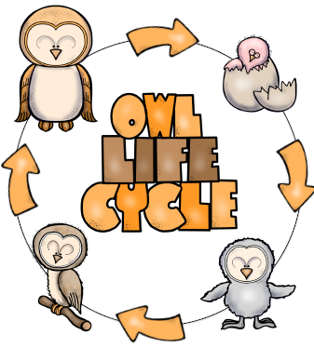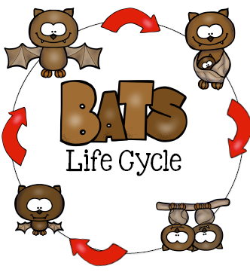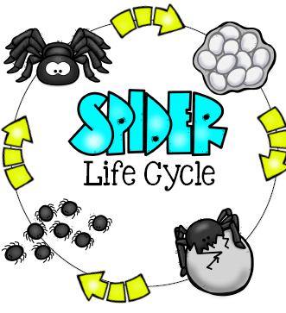  Life Cycles of Bats (mammal),  Owls (bird), and Spiders (arachnid) | Florida Office of Early Learning:  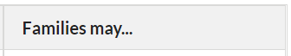  - Read books with children about plants and animals and life cycles. All living things go through a life cycle.
V. MATHEMATICAL THINKING  A. NUMBER SENSE  V. A. 5. Constructs and counts sets of objects (one to 10 and beyond) | 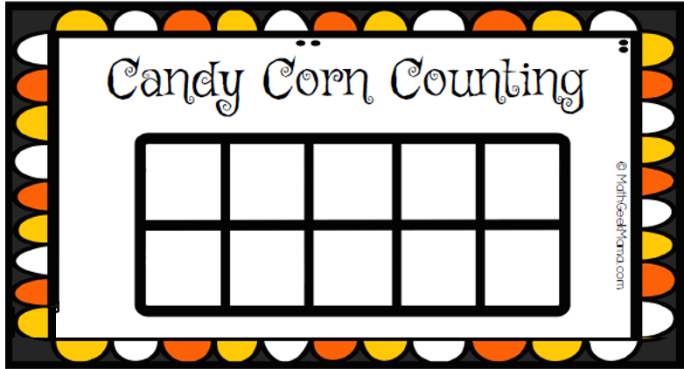 | Florida Office of Early Learning:  - Ask for children’s help in distributing items like snacks, or in laying napkins out on the dinner table (e.g., one napkin per plate).
FAITH FORMATION-Knows that God loves, protects and provides for them.  SAFE ENVIRONMENT STANDARDS  Standard 2- Spiritual Development  SESD:2f an understanding that God calls us to forgive those who hurt us | Crossing of the Red Sea  Exodus 13-15  Escape from Egypt [people didn’t always have faith] Exodus 16-17 | During this unit we are reading Old Testament Bible stories and learning about sin.  As you read picture book Bible stories with your child, you could discuss the consequences to sin and also forgiveness.

News: Please donate a bag of peanut free treats for our Halloween Parade on Monday, October 31. Thank you if you already have brought in a bag of treats!

