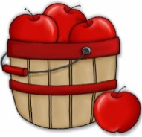
Peek at Our Week
Standard Focus | Activity | Home Extension Activity
IV. LANGUAGE AND LITERACY  F. EMERGENT READING  2. Shows age-appropriate phonological awareness-Listens and matches rhythm, volume and pitch of rhymes, songs and chants  3. Shows alphabetic and print knowledge  IV. F. 3. a. Recognizes that print conveys meaning | 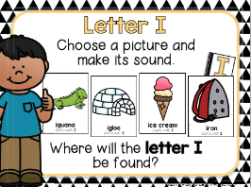  Our letter this week is "Ii”  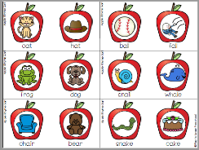  Apple Rhyming | Read rhyming picture books together.  As you read, occasionally point out words that rhyme. (“Oh, goat and boat rhyme! They sound the same at the end. Goat, boat.”) See Parent Resources below for a list of rhyming books, that you may be able to find at the library.
A. SCIENTIFIC INQUIRY  1. Uses senses to explore and understand their social and physical environment  VI. A. 1. b. Begins to identify and make observations about what can be learned about the world using each of the five senses  B. LIFE SCIENCE  1. Demonstrates knowledge related to living things  VI. B. 1. c. Understands that all living things grow, change and go through life cycles | 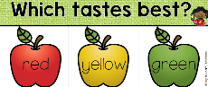  Sense of Taste and  Sight (colors) Apple Taste Test  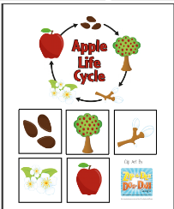  Apple Life Cycle | Florida Office of Early Learning:  - Read books with children about plants and animals and life cycles.
V. MATHEMATICAL THINKING  A. NUMBER SENSE  V. A. 4. Identifies the last number spoken tells “how many” up to 10 (cardinality) | 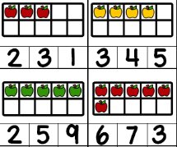  Counting within a  ten frame | Florida Office of Early Learning:  - Find authentic reasons to count things around the house and outdoors. Remember to ask the question, “How many?” once the counting sequence is complete.
FAITH FORMATION  Knows that God loves, protects and provides for them.  SAFE ENVIRONMENT STANDARDS  Standard 2- Spiritual Development  SESD:2f an understanding that God calls us to forgive those who hurt us | Joseph’s Coat of many colors and how his brothers tricked and sold him to the Ishmaelites Genesis 37  Joseph helping his family once he was in Egypt and how Joseph forgives his brothers  Genesis 42-45 | Read and discuss these Old Testament stories using a children’s picture bible.

Parent Resources: https://blog.allaboutlearningpress.com/rhyming-picture-books/
Other News:

