Standard | Activity | Home Extension
VII Social Studies  B. Individual Development and Identity  1 Begins to recognize characteristic of self as an individual | Go to the mirror and point out on each child where their eyes, ears, nose, mouth, and hands are. Ask them if they can find any other body parts such as bellies, cheeks, tongue, etc. | Take the time to talk to your child about differences in themselves and others they see. Talk about your personal preferences and ask what they like. Encourage the individuality of your child.
VI Scientific Inquiry  Scientific Inquiry through exploration and discovery  Uses sense to explore and understand their social and physical environment  Benchmark a. Identifies sense organs | Introduce Mr. Potato head. See how many body parts they can identify correctly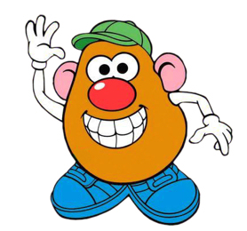 | Talk about their own body parts and your own. Start expanding on different body parts that they may not know
VII Creative Expression Through the Arts  C. Creative Movement  1. Beings to engage in individual and group movement activities to express and represent thoughts, observations, imagination, feelings, experiences, and knowledge | Sing the song “Head Shoulders Knees and toes” and allow the children to touch those parts of their body. Sing really slow and gain speed for a fun game. | Let your child pick a fun, fast song to dance to. Ask him/her to make a dance move and then copy what he/she does. Take turns going back and forth copying each other's dance moves.

