Peek at Our Week
Standard Focus | Activity | Home Extension Activity
- Skill Streaming: Problem solving | Five Little Pumpkins Sitting on a Gate Challenge  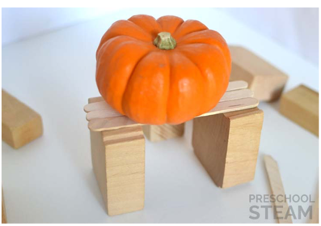  The children will be presented with a variety of materials and asked to build a gate strong enough and long enough to hold 5 small pumpkins. | You can create your own challenges at home. See if they can make a tunnel or bridge. Can they make a table strong enough to hold a small car or other toy?  Can they build a tower as tall as the couch?  Use your imagination and I’m sure you will be able to think of many challenges for your child.
- Develops independence through coordinated and purposeful movements and activities  - Demonstrates awareness of own body in space | The children will be encouraged to engage in activities which help them become aware of own body in space such as spinning in the teacup, hanging from the monkey bars, climbing on the rainbow climber, using the balance beam, and swinging on the belly swing. | Other vestibular activities which can be done at home are jumping on a trampoline, yoga, rocking in a hammock, swinging, spinning in a swivel chair, somersaults and rolling like a log.

