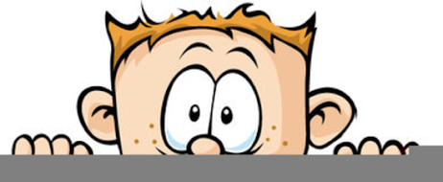

Peek at Our Week
Standard Focus | Activity | Home Extension Activity
- Begins to use senses to observe and experience the environment  - Uses senses to explore and understand their social and physical environment | Touch bag game:  Place items in a bag and have the children put their hand in and identify the object just using their sense of touch. | Make a touch bags at home using a pillowcase and items around your house. Take turn putting your hand in the bag and guessing what you chose.
- Begins to use senses to observe and experience the environment  - Uses senses to explore and understand their social and physical environment | While eating apples slices, apple chips, dried apples and apple sauce concentrate on feeling and describing the different textures of each item. Record the children’s responses and hang in room. | You could do a similar activity using potatoes. Eat mashed potatoes, French fries and potato chips. Talk about how each item is made from potatoes but looks and feels different.
- Engages in physical activities with increasing balance, coordination, endurance and intensity  - Engages in active physical play for short periods of time  - Develops independence through coordinated and purposeful movements and activities  - Demonstrates awareness of own body in space  - Recognizes a simple AB pattern (e.g., clap/snap, clap/snap, clap/snap) | Music and Movement using  YoRiMeKids.com  Prodigies.com  The children will repeat patterns, do yoga to music, and use steppingstones for improve balance. | You can work on AB patterns at home by having your child repeat simple patters such as clap, jump, clap, jump or soft voice, loud voice, soft voice, loud voice or stand up tall, bend down low, stand up tall, bend down low.
Parent Resources: Our focus this week is touch.

