Peek at Our Week
Standard Focus | Activity | Home Extension Activity
- Uses imagination and creativity to express self through open-ended, diverse and process-oriented art experiences with intention | Apple Stamp Painting  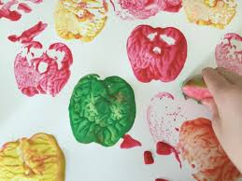 | Try stamping with fruits and vegetables at home. Apples, celery, carrots, or corn are some good choices to use for stamping. Just put some paint on a sponge and press the item on to the sponge and stamp away on a large piece of paper.
- Uses senses to explore and understand their social and physical environment  - Identifies sense organs  - Begins to use senses to observe and experience the environment | Observe apples using our sense of sight.  Look at the color, shape and size of different varieties of apples. Cut an apple from top to bottom and another from side to side and compare the differences. | Invite your child into the kitchen when you are preparing fruits and vegetables. Let them see the inside of a green pepper. Explore the outside of a pineapple. Husk some corn.
- Compares sets of objects by one attribute (e.g., sort by size) | “Apple” Sorting with red and green pompoms with tweezers | Sorting activities are all around your home. Sort socks by color or size. Sort clothes by who the belong to. Sort fruits and vegetables by color. Sort pastas by shapes.
Parent Resources: For the next 8 weeks, we will be using our senses to explore apples, pumpkins, and corm. This week we are focusing on sight.

