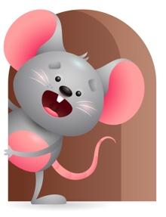
Peek at Our Week

Standard Focus | Activity | Home Extension Activity
Social Studies- Younger-recognizes familiar people and objects. Older-Begins to respond to schedules. | Younger-show them different pictures of objects, family members, and peers- name each picture and tell them what or who it is. Older- using pictures show them when it is lunch time-play time- nap-outside time and time to go home. | Younger- look through a photo album with them and tell them who everybody is. Look at books and name the things you see in it. Older- through repetition tell them it is lunch time (what shall we eat?) play time (get some toys out) nap time (play soft music) outside time (let us go for a walk).
Creative Expression-Younger- uses movement to show increasing body awareness in response to own environment. Older-responds to music in a variety of ways. | Younger- move their hands and feet for them and show them what they can do. Play pat-a-cake with their feet and peek-a-boo with their hands. Older-play music and listen to the sounds- use your hands and feet and move your body to the sound. Sing and do the motions. | Younger- play music and show them ways they can move their bodies. Sit on the floor and do some movements with them (clap your hands, stomp your feet, wiggle your fingers, touch your toes). Older- play some music and do some simple body movements and see if they will copy you.
Physical Development-Younger- explores new body positions and movements. Older- uses each new posture to learn new ways to explore the environment. | Younger- practice crawling, sitting without help, hitting, and kicking at objects. Older-explore the environment and practice reaching for toys. Explore the objects in your hands and see what they do. Practice pulling up on things to stand. | Younger- put toys in front of your child to where they have to reach or crawl to get them. Offer them things that they can hit or kick at. Practice helping them to sit without help. Older- give them different objects to explore and let them have fun seeing what they can do. Let them practice pulling up to stand.

Parent Resources

Other News- We will read The Character Kid book and see all the Kind things that Scooter does. How can we be kind? We will practice this week by playing together and sharing our toys.

