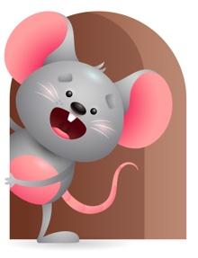
Peek at Our Week

Standard Focus | Activity | Home Extension Activity
Social Studies-Younger- Responds and recognizes people and objects. Older- Time, continuity and change- begins to respond to schedules. | Younger- pick up different objects and name them. Play a game where is (child’s name) I don’t know. (use Mommy and Daddy too). Older- Through repetition talk to them and say we had our morning snack-it is time to go outside- Nap is over-it is lunch time. | Younger- through the day show them pictures and tell them what or who it is- name different objects in the house- table-chair-bed. Older- through the day tell them it is Play Time-Lunch-Nap-outside- time to go to the store.
Mathematical Thinking-Younger- Explores objects in hands. Older-Observes songs and finger plays with numbers. | Younger- Let them explore the blocks in their hands while you stack them and count to 3. Older-Do finger plays- here is the beehive- 5 little monkeys- 5 green and speckled frogs-use hand puppet. | Younger- While using their senses count the objects you give them to explore in their hands. Older- do some simple finger plays that involves numbers.
Scientific Inquiry- Younger- Uses senses to explore and understand their social and physical environment. Older- Displays interest in movement of objects. | Younger- let them explore different textures with you and read the touch and feel books. Older- watches an object move and is curious why it stopped. Play with the cars and roll them back and forth to each other. | Younger- give them different textured materials and objects and let them explore them using their senses. Older- let them watch objects move and stop-show them how they work.

Parent Resources

Other News- This week is Ricky- He is Honest. Try to show them that when they take a toy from their friend, they need to give it back because it was their turn to play with it. Ask them to wait their turn and share. Show them how.

