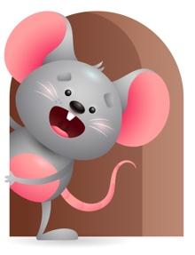
Peek at Our Week

Standard Focus | Activity | Home Extension Activity
Social Emotional-Younger- Shows recognition of familiar adults and imitates their facial expressions. Older- Uses sounds, facial expressions and gestures to respond to caregiver interactions and express a range of emotions. | Younger- Introduce the Character Kid Book and words like cooperative and kind. Talk to the them and say things like you gave your toy to them -that is being kind-you are lying still while I change your diaper- that is being cooperative. Older- Sing Happy and you know it and do the motions and facial expressions. | Younger- show them different facial expressions and tell them this is what it looks like when you are cooperative (Happy-Smile). When you will not eat (Sad-make a sad face). Older- Look in a mirror with them and make facial expressions at them and tell them what it is-Happy-Sad -Mad- see if they imitate you.
Approaches to Learning-Younger- Tries to produce interesting and pleasurable outcomes. Older- Shows interest in and excitement about objects and people. | Younger- Floor Time-explore the toys and see what sounds they make and what they do. Older- Sing Head Shoulders Knees and Toes and practice doing the motions with them. | Younger- Sit on the floor and play with them they really enjoy when someone is down there. Build blocks-roll balls- sing and move around- make it fun. Older- Show them some toys that move and make sounds it will spark their interest and they will be excited.
Creative Expression-Younger- Uses movement to show body awareness. Older- Responds to music in a variety of ways. | Younger- while on the floor help them to lift their legs- reach for the sky- touch their toes-clap their hands. Older- Sing Teddy Bear, Teddy Bear, turn around- and do the motions. | Younger- play games like pat-a-cake-this little piggy- exercise on the floor with them. Older- Play music and get them to move around-show them how to clap-shake -bounce- move their feet all around.

Parent Resources

Other News- This week is Alex-He is Brave-we will be brave and practice pulling up on things and standing on our own and who knows we might just take a few steps. Practice using Brave Talk with them encouraging them to Try new things and don’t give up.

