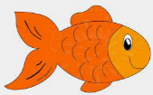
Peek at Our Week
Standard Focus | Activity | Home Extension Activity
IV. LANGUAGE AND LITERACY  F. EMERGENT READING  2. Shows age-appropriate phonological awareness  3. Shows alphabetic and print knowledge  IV. F. 3. a. Recognizes that print conveys meaning | Our letter this week is "Dd"  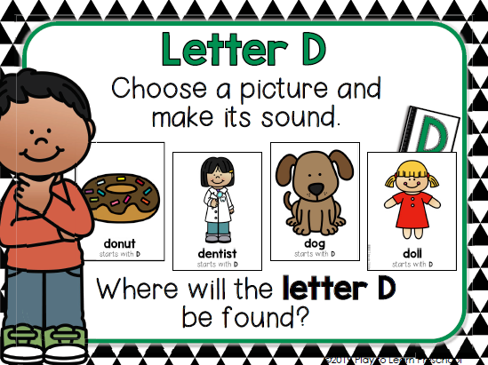 | 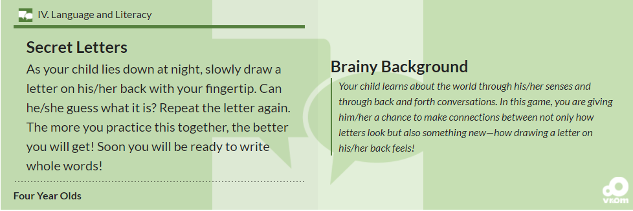
FAITH FORMATION  Plays, works and prays happily with others.  Develops a sense of awe and wonder, respect, gratitude and stewardship for God’s creation. | 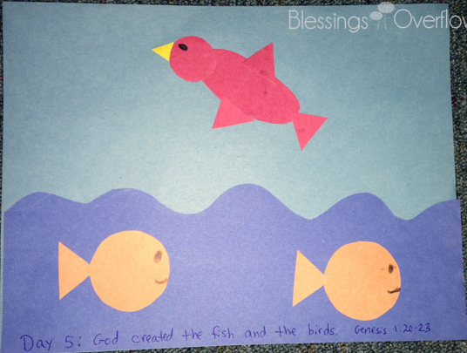  God created the fish and the birds. Genesis 1:20-23 | Read, look at pictures, and discuss “Creation” in a children’s picture Bible.  Read books about plants and animals and their characteristics.
I. PHYSICAL DEVELOPMENT  A. HEALTH AND WELLBEING  d. Feeding and Nutrition  I. A. d.1. b. Recognizes nutritious food choices and healthy eating habits | 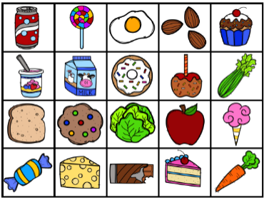  We will be sorting pretend food into categories of “Healthy/Growing Food” vs “Food that we eat for Treats Sometimes.” | Discuss which foods you eat throughout the week that are healthy “growing” foods, that are important to eat each day.

VII. SOCIAL STUDIES  B. Individual Development and Identity  3. Recognizes individual responsibility as a member of a group (e.g., classroom or family)  Safe Environment Standards  SECD: 1d There are “good” and “bad” choices | 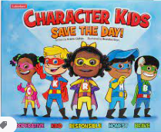  Book: Character Kids SAVE THE DAY! [Emphasis on “Responsible- Keisha”] | Families may...  - Discuss individual and shared responsibilities in the family (e.g.,  “I go to work, and you go to school.” “I will put the plates away. You sort the spoons and forks.”).

Parent Resources: "Literacy Home Extension Activity" and Social Studies’ Home Extension ideas taken from this website:
Florida Early Learning Developmental Standards and Professional Competencies
http://www.floel.org/standardsresource/details.html#p=resources/IV/four_year_olds/F/3/Benchmark%20b&d=IV,V&a=four_year_olds

Other News:

