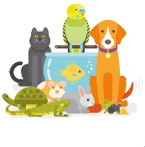
Peek at Our Week
Standard Focus | Activity | Home Extension Activity
IV. LANGUAGE AND LITERACY  F. EMERGENT READING  2. Shows age-appropriate phonological awareness-Listens and matches rhythm, volume and pitch of rhymes, songs and chants  3. Shows alphabetic and print knowledge  IV. F. 3. a. Recognizes that print conveys meaning | 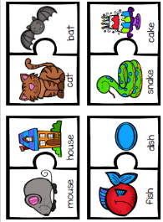  Rhyming Words | 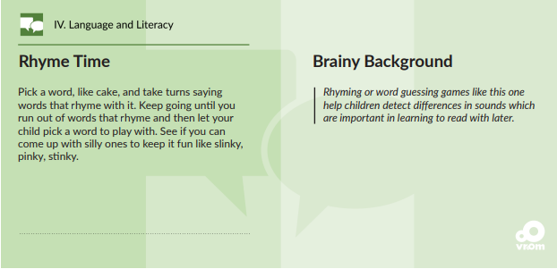
IV. LANGUAGE AND LITERACY  F. EMERGENT READING  3. Shows alphabetic and print knowledge  IV. F. 3. a. Recognizes that print conveys meaning | 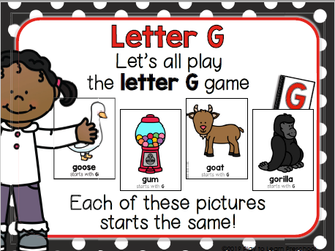  Our letter this week is "Gg" | Florida Office of Early Learning:  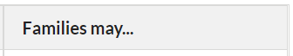  - Sing the alphabet song with children while they are following along looking at the letters.  - Point out words that begin with the same letter as children’s names (e.g., John and jump)
FAITH FORMATION  Faith Development Concepts:  Develops a sense of awe and wonder, respect, gratitude and stewardship for God’s creation.  Ask for and listens to Bible stories. | Creation: REVIEW of Days 1-7  Putting our Creation Pictures together into a book, and making a cover.  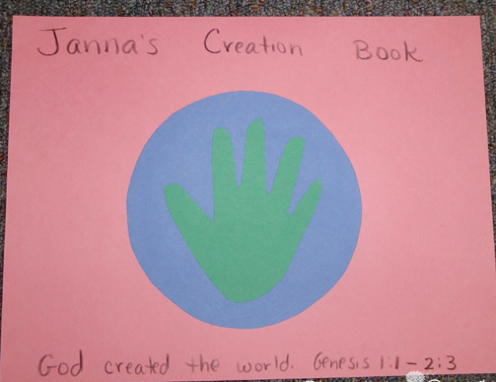 | We will be sending home the Creation Book that your child has made during this unit. You may occational read and look through the pictures he/she made. Perhaps they will want to talk some of the pictures with you.

V. MATHEMATICAL THINKING  V. A. 5. Constructs and counts sets of 0-10 objects  D. GEOMETRY  V. D. 1. Recognizes and names two-dimensional shapes (circle, square, triangle and rectangle) of different size and orientation | Count 6 objects; Sorting  arrange and count Shapes  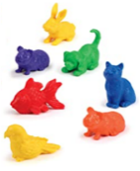  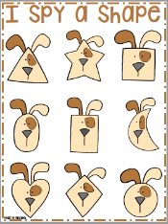  them in scattered &  linear configurations. | 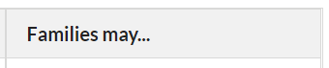Cut a cereal box into different shapes. Children can put them together in different ways to make different things, or sort the shapes by how many sides they have.  [From Florida-Office of Early Learning]
V. MATHEMATICAL THINKING  A. NUMBER SENSE  V. A. 3. Demonstrates one-to-one correspondence when counting objects.  V. A. 4. Identifies the last number spoken tells “how many” up to 10.  V. A. 5. Constructs and counts sets of objects.  V. A. 7. Reads and writes some numerals one to 10 using appropriate activities | Match the numerals to quantities.  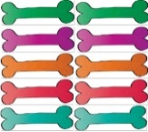  Feed the dog. | Florida Office of Early Learning:  - Play number games with children by rolling dice or use a number card, move that many spaces.

Parent Resources:

Other News:

