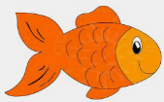
Peek at Our Week
Standard Focus | Activity | Home Extension Activity
IV. LANGUAGE AND LITERACY  F. EMERGENT READING  2. Shows age-appropriate phonological awareness  IV.F.2.d.Combines syllables into words (e.g., “sis” + “ter” = “sister”)  3. Shows alphabetic and print knowledge  IV. F. 3. a. Recognizes that print conveys meaning | Our letter this week is "Ff"  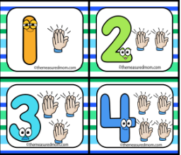  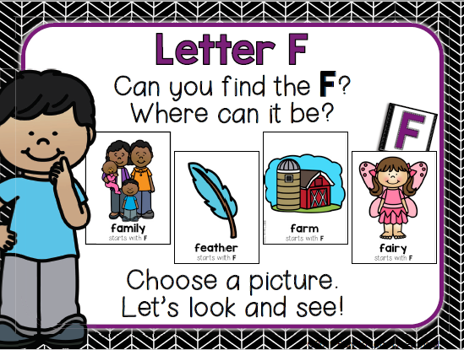  How many syllables  in my name? | Families may...  - Collect some small household items (pencil, block, cookie, toothpaste, cup, etc.) or pictures and place them in a box or small bag. The adult removes one item, says its name and asks children how many “claps” it has. Say the object name again, clapping as the adult says each syllable. Then it is the children’s turn to take an item out of the box, say the name and clap the syllables.
IV. LANGUAGE AND LITERACY  F. EMERGENT READING  3. Shows alphabetic and print knowledge  IV. F. 3. a. Recognizes that print conveys meaning  C. VOCABULARY  2. Uses increased vocabulary to describe objects, actions and events (expressive)  IV. C. 2. a. Uses a large speaking vocabulary, adding new words weekly (e.g., repeats words and uses them appropriately in context) (typically has a vocabulary of more than 1,500 words) | Our letter this week is "Ff"  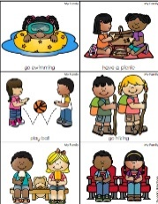  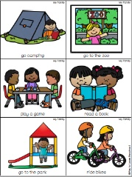  The children will share what kinds of activities they like to do with their families | 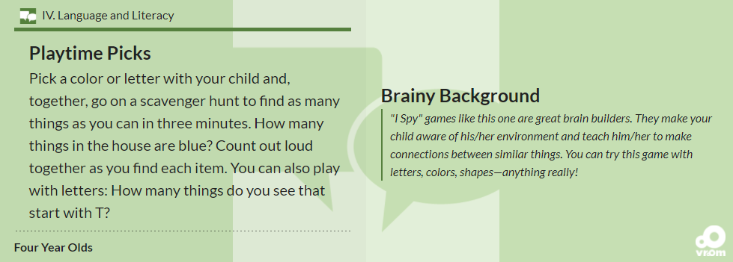  Florida Office of Early Learning shares an idea to help your child increase expressive vocabulary
V. MATHEMATICAL THINKING  A. MEASUREMENT and DATA  4. Represents, analyzes and discusses data (e.g., charts, graphs and tallies) | 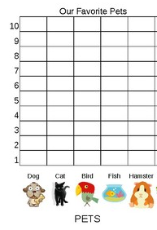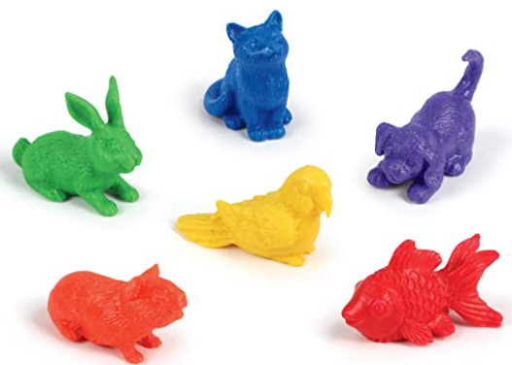 | Families may...  - Take surveys and use tally marks to answer such questions as, “What do you want for dinner?” or “Where do you want to go for a special family outing?”

FAITH FORMATION  Recognizes that prayer is talking to God.  SAFE ENVIRONMENT STANDARDS  Standard 2- Spiritual Development  SESD:2e A sense that God loves all individuals and gives us families composed of members who help each other | Creation: Day 7  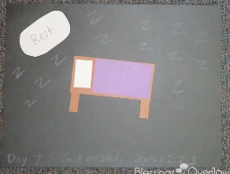  God rested. (Genesis 2:2-3) | *****Praying Together as a Family  A Strong Foundation  A strong foundation is the key to any construction. It’s the same with prayer. More advanced forms of prayer are wonderful, but they only bear fruit if our foundation is solid.  This is part of why, when the disciples asked Him how to pray, Jesus directed them away from complicated formulas or recitations: “Do not babble like the pagans who think they will be heard by their many words.” (Matthew 6:7) Simple prayers shift our focus away from our words and make space for God to speak to us.

Parent Resources: *****Praying Together as a Family: https://marriagefamilylife.seattlearchdiocese.org/prayer

Other News:

