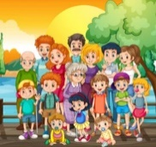
Peek at Our Week
Standard Focus | Activity | Home Extension Activity
IV. LANGUAGE AND LITERACY  F. EMERGENT READING  IV. F. 2. b. Combines words to make a compound word (e.g., “foot” + “ball” = “football”)  3. Shows alphabetic and print knowledge  IV. F. 3. a. Recognizes that print conveys meaning | Our letter this week is "Ee"  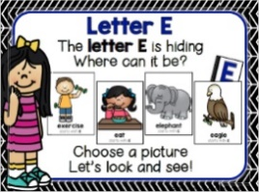  Compound Word Practice  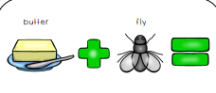  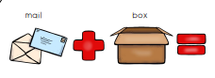 | Families may...  - Play a word game, saying the first part of a compound word and asking children to provide a variety of second words that make real compound words (e.g., say “sun” and encourage responses like “flower,” “shine” and “burn.”).
V. MATHEMATICAL THINKING  F. MEASUREMENT AND DATA  V. F. 3. Seriates (places objects in sequence) up to six objects in order by height or length (e.g., cube towers or unit blocks) | Size sequencing  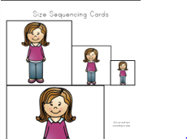Smallest to Largest and Largest to smallest | Families may...  - Provide fun experiences at home by asking children to sequence containers of food, such as cereal boxes or canned goods, found in the kitchen cabinets. Begin with three-four items and increase up to six items as children are able to order the items and describe the arrangements they have made according to size.
V. MATHEMATICAL THINKING  A. NUMBER SENSE  V. A. 6. Uses counting and matching strategies to find which is more, less than or equal to 10 | 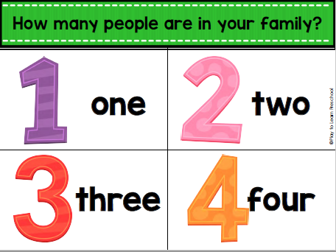  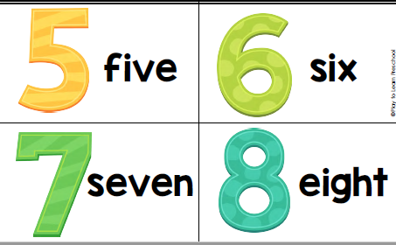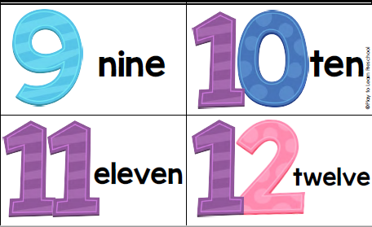 | Count the number of people in different families you know. Compare the numbers--more than, less than.

FAITH FORMATION  Plays, works and prays happily with others.  Develops a sense of awe and wonder, respect, gratitude and stewardship for God’s creation.  VI. SCIENTIFIC INQUIRY  B. LIFE SCIENCE  1. Demonstrates knowledge related to living things and their environments  VI. B. 1. a. Identifies characteristics of a variety of plants and animals including physical attributes and behaviors | 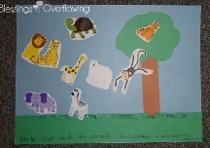  God made the animals.  Genesis 1:27-31  We will learn about animals, and some of the characteristics of animals. We will talk about which animals are wild and which can be pets. | Read, look at pictures, and discuss “Creation” in a children’s picture Bible.  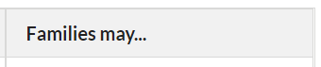Read books about animal adaptions or animal homes/habitats (e.g., animals living in different places have special features that help them to survive). [From Florida-Office of Early Learning]

Parent Resources:

Other News:

