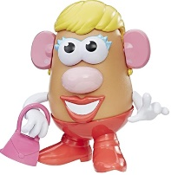
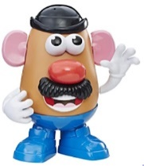
Peek at Our Week
Standard Focus | Activity | Home Extension Activity
IV. LANGUAGE AND LITERACY  IV. LANGUAGE AND LITERACY  F. EMERGENT READING  2. Shows age-appropriate phonological awareness  3. Shows alphabetic and print knowledge  IV. F. 3. a. Recognizes that print conveys meaning | Our letter this week is "Cc"  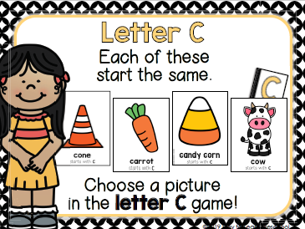  We also will be learning about parts of our bodies (head, arms, legs, neck, hand, etc.). | Write the letters Aa, Bb, and Cc on separate pieces of paper. Look for a few items around your home that start with the short /a/ sound as in “apple,” the /b/ sound as in “banana”, and the hard /c/ sound as in “candle.” Have your child sort the items into either an “Aa,” “Bb,” or “Cc” group, according to their beginning sound.  You may play a brief game of “Simon Says” with your child to reinforce the names of our body parts. (e.g., “Simon says touch your elbow”).
VII. SOCIAL STUDIES  B. INDIVIDUAL DEVELOPMENT AND IDENTITY  VII. B. 1. Identifies characteristics of self as an individual  VII. B. 2. Identifies the ways self is similar to and different from peers and others  D. SENSE OF IDENTITY AND BELONGING  4. Develops sense of self-awareness and independence  Benchmark c.  Uses words to demonstrate knowledge of personal information (e.g., hair color, age, gender or size) | 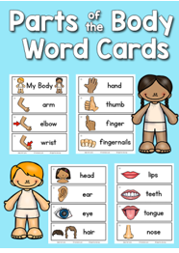  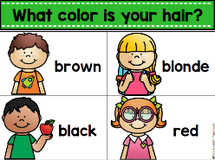  All About Me  Charting our hair colors Learning about  the parts of the body  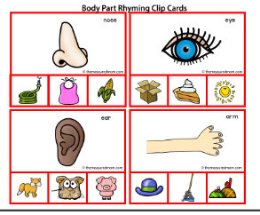  Rhyming with body part words | Have your child discuss different attributes (such as eye color, hair color, what they are good at) that make them an individual. You can help your child compare the attributes with other family members.  - Sing songs and play games that help children recognize their own unique characteristics (e.g., riddles…”Who has brown hair in our family? Who has green eyes and likes pizza?”).

FAITH FORMATION  Develops a sense of awe and wonder, respect, gratitude and stewardship for God’s creation.  VI. SCIENTIFIC INQUIRY  D. EARTH AND SPACE SCIENCE  VI. D. 1. c. Begins to explore and discuss simple observations of characteristics and movements of the clouds, sun, moon and stars | 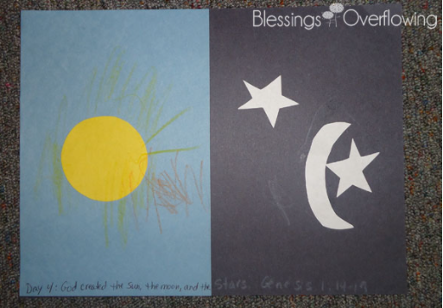  God created the sun, moon, and stars. Genesis 1:14-19  We will discuss the sun, moon, and stars:  -our sun is a star  -we see the sun during the day  -we can see other stars and the moon at night  -sometimes we can see the moon during the day also | Florida Office of Early Learning:  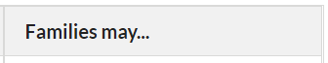  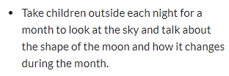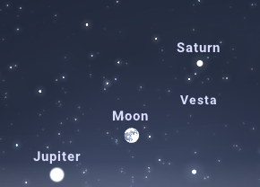  During the month of September, the Full Moon will be visible in the evening eastern sky Friday, September 9th (if there are no clouds). The planet Saturn will above and slightly to the right and Jupiter will be just below the moon near the horizon.
III. SOCIAL AND EMOTIONAL DEVELOPMENT  C. BUILDING AND MAINTAINING RELATIONSHIPS WITH ADULTS AND PEERS  2. Develops positive relationships with peers  III. C. 2. c. Responds appropriately to bullying behavior  3. Develops increasing ability to engage in social problem solving  III. C. 3. a. Able to independently engage in simple social problem solving including offering potential solutions and reflecting on the appropriateness of the solution | 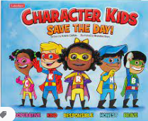 Character Kids SAVE THE DAY! [Emphasis on “Honest-Ricky”] | Florida Office of Early Learning:  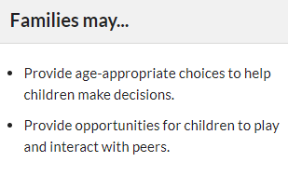

Other News:

