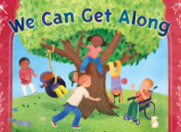
Peek at Our Week
Standard Focus | Activity | Home Extension Activity
IV. LANGUAGE AND LITERACY  G. EMERGENT WRITING  1. Begins to show motivation to engage in written expression and appropriate knowledge of forms and functions of written composition  IV. G. 1. a. Intentionally uses scribbles/writing to convey meaning (e.g., signing artwork, captioning, labeling, creating lists, making notes) | Our letter this week is "Bb"  In addition to learning about letters and their sound(s), we are talking about how to write the letter.  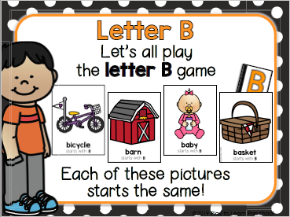 | Offer paper and something to write with (pencil, colored pencil, marker) to your child. In class I am looking at how the children are holding pencils and markers.  As you watch your child draw or write, notice if he/she is using a “whole hand” grip or a “three-point finger” grip. If she/he is using a “whole-hand” grip, gently move the fingers into a “three-point finger” grip.
SAFE ENVIRONMENT STANDARDS  Standard 3- Behavioral Development  SEBD: 3b Understanding that feelings can be managed.  SEBD: 3c How friends treat each other with respect. (Treating friends with respect builds character. The Character Kids.) | 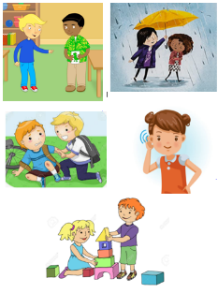 | Scholastic  13 Ways to Raise a Caring and Compassionate Child  https://www.scholastic.com/parents/family-life/social-emotional-learning/social-skills-for-kids/13-ways-to-raise-caring-and-compassionate-child.html
V. MATHEMATICAL THINKING  D. GEOMETRY  V. D. 2. Describes, sorts and classifies two- and three-dimensional shapes using some attributes such as size, sides and other properties | Sorting objects into groups in two different ways (size and color): | Sort toys or other objects at home by an attribute such as size, color, type of toy, matching socks, dad’s clothes vs. child’s clothes, etc.

III. SOCIAL AND EMOTIONAL DEVELOPMENT  A. EMOTIONAL FUNCTIONING  2. Develops positive relationships with peers  III. C. 2. c. Responds appropriately to bullying behavior  3. Develops increasing ability to engage in social problem solving  III. C. 3. a. Able to independently engage in simple social problem solving including offering potential solutions and reflecting on the appropriateness of the solution | 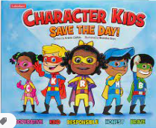 Character Kids SAVE THE DAY! [Emphasis on “Brave-Alex”] | Florida Office of Early Learning:  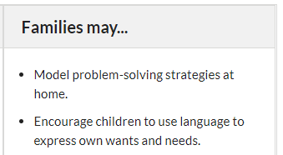

Parent Resources:

Other News:

