Peek at Our Week
Standard Focus | Activity | Home Extension Activity
F. EMERGENT READING  3. Shows alphabetic and print knowledge  IV. F. 3. a. Recognizes that print conveys meaning  A. LISTENING AND UNDERSTANDING  1. Demonstrates understanding when listening  IV. A. 1. a. Engages in multiple back-and-forth communicative interactions with adults | 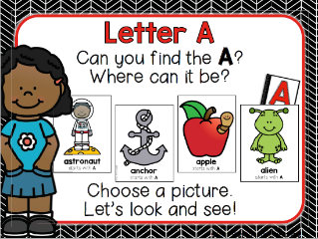  This week we will start with “Our Letter of the Week.” Our letter this week is “Aa.” | Singing the ABCs is always a good practice at this age. Slowing down when you get to the letters  “L, M, N, O, P” helps children hear each letter separately. Also, pointing to the letters as you sing is helpful. Does your child have a letter “Aa” in her or his name? If so, you may point out the letter and make a connection to the ABC song.
FAITH FORMATION  Plays, works and prays happily with others.  Develops a sense of awe and wonder, respect, gratitude and stewardship for God’s creation. | CREATION- On the second day God separated the water from the sky (Genesis 1:6-8).  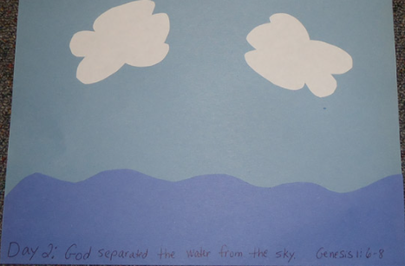 | Here is a Creation Song you may sing at home.  (Sung to the tune of Frere Jacques)  God created! God created!  Night and day, night and day.  That was on the first day.  That was on the first day.  And it was good! It was good!  God created! God created!  Sky and clouds, sky and clouds.  That was on the second day.  That was on the second day.  And it was good! It was good.
V. MATHEMATICAL THINKING  V. C. 1. Identifies and extends a simple AB repeating pattern | ABAB Pattern Practice | 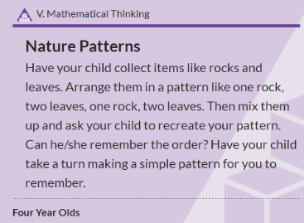

Standard Focus | Activity | Home Extension Activity
III. SOCIAL AND EMOTIONAL DEVELOPMENT  A. EMOTIONAL FUNCTIONING  1. Expresses, identifies and responds to a range of emotions  III. A. 1. a. Recognizes the emotions of peers and responds with empathy and compassion  B. MANAGING EMOTIONS  1. Demonstrates ability to self-regulate  III. B. 1. a. Recognizes and names own emotions and manages and exhibits behavioral control with or without adult support | 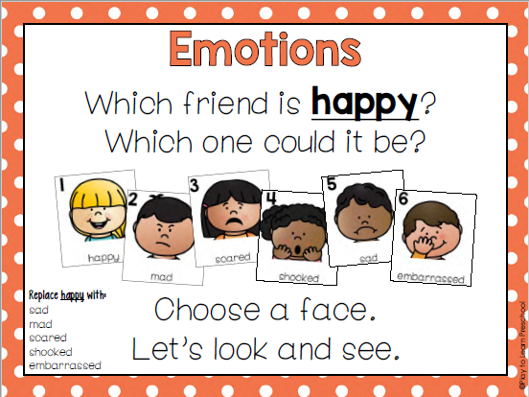  We will be learning about our Feelings/Emotions this week.  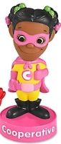  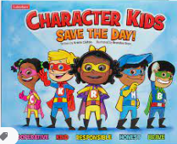 Character Kids SAVE THE DAY! [Emphasis on “Cooperative- Brandy”] | Sung to the tune Hokey Pokey:  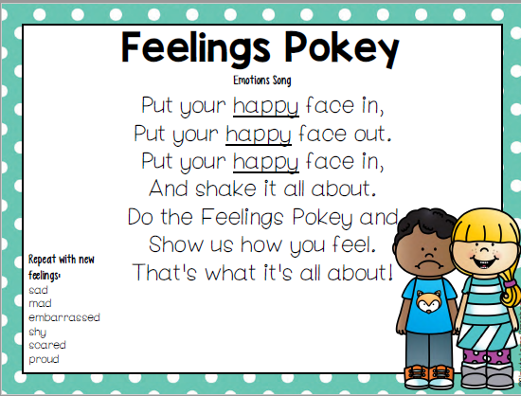

Parent Resources:

Other News:
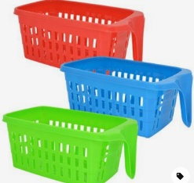
- We are requesting parents to bring in a shoe box size plastic container. We will be putting your child’s name and animal symbol on the container and use these on our cubby shelf. This will help us contain and separate the students’ water bottles, shoes, etc. I found these at the Dollar Tree in Dade City:

