Peek at Our Week

Skill Streaming Focus: Using Brave Talk
Character Kid Focus: Alex – Brave

Florida Early Learning and Developmental Standards | School Activity | Home Extension Activity
Religious Focus: Creation – Day Three  - “Let there be dry land and plants.” | 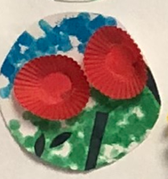  This is an example of what the children will be making to represent the creation of land and plants. | Children enjoy taking care of things, so now might be a good time to plant some flowers in a pot for your child to water and take care of.
Language and Literacy  - Uses verbal and nonverbal communication and language to express needs and feelings, share experiences and resolve problems | Emotions Matching Game:  Each child will be asked to find a picture of an emotion from a large number of different depictions of that emotion | Learning to identify and respond appropriately to their own feelings and those of others is a focus of this year. When reading books point out how the characters are feeling. Ask your child how they know what the character is feeling? They might respond by saying that the character has tears in his eyes so he must be sad, or she is smiling so she is happy. Ask why the character is feeling this way and what could be done to make them feel better if it is a difficult emotion.
Mathematical Thinking  - Begins to demonstrate an understanding of basic spatial directions through songs, finger plays and games | Using blocks practice positional words  Such as:  Put this block at the back of the line of blocks.  Put this block beside the large block. | Hide a toy and then emphasize positional words while verbally guiding your child to the toy. For example, “The car is hiding under the blanket”, “The doll is hiding next to the plant.”, or “The red block is behind the box”.

