Peek at Our Week

Skill Streaming: Using Nice Talk
Character Kid Focus: Brandy – Cooperative

Florida Early Learning and  Developmental Standards | School Activity | Home Extension Activity
Religious Focus: Creation – Day Two  - “Let there be clouds and seas.” | 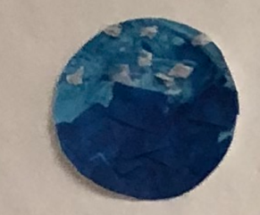  This is an example of what the children will be creating to represent the creation of clouds and seas. | This time of year is great for cloud watching. Go outside and looks at the clouds. Discuss the different shapes, sizes and colors. Look for clouds that resemble objects.
Language and Literacy  - Demonstrates understanding when listening  - Engages in multiple back-and-forth communicative interactions with adults and peers during creative play and in purposeful and novel situations | Listening Game:  Finish my line  Ask the child to finish your sentences. You can use popular children’s songs, poems, or everyday phrases, e.g., “Twinkle, twinkle little…” | This Listening Game can be easily played at home with your favorite songs, repetitive books and phrases.
Language and Literacy  - Demonstrates understanding when listening  Social Studies  - Begins to recognize expectations in varying settings | Voice Modulation Game  Sing “I have a Soft Voice” song first using a normal tone of voice, then sing it loudly, then as a whisper, and finally using a normal soft voice again. | Play the Voice Modulation Game at home with a song you know such as Twinkle, Twinkle Little Star. Remember the goal is to teach your child how to use a soft or normal tone of voice and how to change their tone when asked to use a soft voice or a whisper or to be completely quiet.

