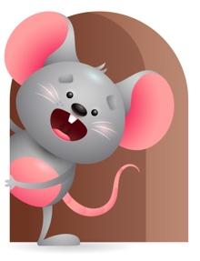
Peek at Our Week

Standard Focus | Activity | Home Extension Activity
Physical Development- Younger Babies -Demonstrates use of large muscles-explores new body movements.  Older-Demonstrates large muscles to move in the environment. | Younger Babies-practice rolling from back to stomach and sitting with help or without. Older-we will practice sitting with balance so we can reach for or hold objects. Talk about what their Hands can do? What can you do with your legs and feet? | Younger Babies -Practice putting them on their stomach and helping them to roll over-Hold them up so they can strengthen their backs. Older- let them practice reaching for toys while sitting.
Approaches to Learning-Younger Babies -Persistence- Attends to sights and sounds. Older-Creativity and Inventiveness-Notices and shows interest in objects and people. | Younger Babies-Continue to practice being on tummy and explore how things work and sound-we will drop different things in the bucket to see how they sound. We will do it over and over for repetition. Older- We will explore what our bodies can do by clapping our hands, walking with a toy, stacking blocks. We will sing Happy and you know it and do the motions. | Younger Babies- Continue to put them on their tummy and help them roll over- Play music or make sounds so they can hear how it sounds. Do it over and over for repetition. Older- Interact on the floor with them and play games where they must use their bodies. Sing to them and get them moving. Have Fun.
Scientific Inquiry-Younger Babies-uses senses to explore and displays interest in various types of material in their social and physical environment- Older-Uses senses to gain knowledge about objects. | Younger babies-we will be exploring a variety of books and letting them touch the different textures in it. Older-We will explore our senses and play a game asking them -can you smell this? Taste this? Feel it? Shake it? | Younger Babies-Continue to let them explore different textures-examples are-water, soft fabric, textured carpet, sandpaper. Older- let them explore their senses some more through finger foods, touching things, smelling things

Parent Resources

Other News- We will be practicing learning daily and table prayers-including the sign of the cross. We will also Greet each other as we come in.

