Standard | Activity | Home Extension
I. Physical Development A. HEALTH AND WELLBEING d. Feeding and Nutrition 1. Responds to feeding or feeds self with increasing efficiency and demonstrates increasing interest in eating habits and making food choices Benchmark b. Begins to recognize nutritious food choices and healthy eating habits | Locusts and Honey Snack (Sunflower butter, celery, pretzel legs drizzled with honey) This week we will be talking about John the Baptist. John was known for eating locust and honey because he lived in the wilderness. During an afternoon snack this week we will be offering the kids their own version of Locusts and Honey.  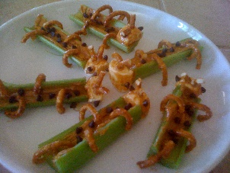 | What are some other healthy foods you can use to create “locusts”? Sit down with your family and create some fun, healthy “locusts” snacks and hold a discussion about “John the Baptist”
I. Physical Development A. HEALTH AND WELLBEING d. Feeding and Nutrition 1. Responds to feeding or feeds self with increasing efficiency and demonstrates increasing interest in eating habits and making food choices Benchmark b. Begins to recognize nutritious food choices and healthy eating habits | The children will get to dip their hands in sticky foods which will symbolize sin and wash it away with water, that will symbolize baptism, as we talk about how John the Baptist baptized Jesus.  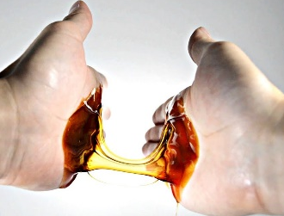 | Let your child help with dinner one night. As their hands get dirty and sticky from the food prep, open up a discussion with them about sin and baptism.
VI. Scientific Inquiry C. PHYSICAL SCIENCE 1. Demonstrates knowledge related to physical science Benchmark a. Explores and investigates objects that require positioning and movement through play (e.g., gears, marble chutes, screws in a toy workbench) | In our science center the children will have a chance to explore different tools and types of screws by using a Screwdriver Board. This is a great fine motor skill that will help build up hand strength for writing. | If you happen to have any small projects around the house that requires screws, offer to have your child help you.

