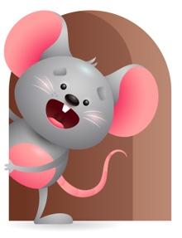
Peek at Our Week

Standard Focus | Activity | Home Extension Activity
Social Studies-Younger- Begins to respond to schedules. Older- Experiences own family practices-food and language. | Younger- Through the day sing when it is time to do something- Play time, Lunch, Nap, Outside Time- just make up the words as you go along. Older- we will taste different foods from home and practice a little sign language like-more, milk, please and thank you. | Younger- Keep doing things like you always do so they can get use to your schedule and routines. Older- Let them experience some of the foods you eat, and practice talking to them in the language you know.
Physical Development-Younger-Demonstrates increasing coordination when using hands for play. Older-Active physical play- demonstrates increasing balance when playing. | Younger- Sing Down on Grandpa’s Farm and do the animal sounds and hand motions with it. Pick up each animal and let them hold it as you make the sound. Older- Do a few exercises with them and see if they will stand on one foot, reach for the sky, touch your toes, turn around, bounce up and down. | Younger- Give them toys they need to try and pull, push, shake, roll. Show them how they work. Older- Help them to balance blocks as they stack them and walk as they carry toys.
Mathematical Thinking-Younger-Explores objects in hands. Older-Observes songs and finger plays that involves numbers. | Younger-Play with animals and let them explore which ones are hard, soft, bumpy. Play with see-n- say and listen to the sounds each one makes. Older-Sing songs and finger plays with numbers. Three little kittens, Ants go marching, This old man, 1,2,3,4,5, once I caught a fish alive, 6,7,8,9,10, then I let him go again. | Younger-Let them explore objects in their hands to see what they can do with it- roll it, push it, pull it, turn it, squeeze it. Older-Sing some songs and finger plays you know with numbers-5 little ducks, baa, baa, black sheep.

Parent Resources

Other News-

