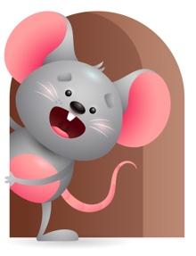
Peek at Our Week

Standard Focus | Activity | Home Extension Activity
Social Emotional-Younger- uses sounds and facial expressions to respond to caregiver. Older-Attends to sights, sounds, and objects. | Younger- Play with dolls and tell them look they are crying. Do you want to see if their wet or hungry? Now their whining should we see if they want to be picked up and held or go to sleep and take a nap? Older- make animal sounds and see if you know what it is-look at objects and see how they work. (cars, trucks, blocks). | Younger- Play with stuffed animals and make facial expressions as you make the sound they do. Older- Show them pictures of animals and tell them what it is, what it eats, where it lives, and the sound it makes.
Language and Literacy-Younger- Increases knowledge through listening-turns head toward familiar sounds. Older- Begins orienting to own name. | Younger- Play the CD Farmer in the Dell- as they listen, they will respond to the sounds. Read the book with it. Older- Read Old McDonald, Farmer in the Dell, and Cows in the kitchen. When reading use the child’s name. | Younger-Read books to them and show them the pictures and tell them what it is and what sound does it make. Older-Read books to them also but use their name throughout the book so they will respond to their name. They love singing so try singing some.
Mathematical Thinking-Younger- Explores objects with different characteristics. Older-Number sense-looking for more than one object. | Younger-Give them different objects to explore, hard, soft, rough, sandy, silky, bumpy. Older-Fill and dump farm animals-count them as you drop them in-hide some and see if they will look for more than one. | Younger- Let them explore different objects while home- squishy, gooey, knobby, types of food, toys, and whatever you can find that would be interesting. Older- Fill and dump different objects and count them as you do. Hide some to see if they will look for more.

Parent Resources

Other News-

