STANDARDS | ACTIVITY | HOME EXTENSION
I. Physical Development B. MOTOR DEVELOPMENT b. Gross Motor Perception (Sensorimotor)1. Uses perceptual information to guide motions and interactions with objects and other people Benchmark a. Begins to act and move with purpose and recognizes differences in direction, distance and location | Jesus Calming the Storm Lesson Game. 2-3 children as the disciples in a ‘boat’ made of masking tape while the other children throw paper balls in the boat. The children in the ‘boat’ must try and get the balls out of the boat. The lesson is to understand how the disciples may have felt during the storm. | Discuss with your child a time in your life when you were scared, but Jesus was able to “Calm your Storm”  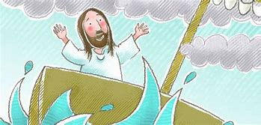
I. Physical Development B. MOTOR DEVELOPMENT b. Gross Motor Perception (Sensorimotor)1. Uses perceptual information to guide motions and interactions with objects and other people Benchmark a. Begins to act and move with purpose and recognizes differences in direction, distance and location | The children will cut out and create their own palm leaves out of green paper and attach to a large popsicle stick as a handle and on Friday the children will hold a Palm Parade around the race track on the playground waving their palms (while singing “Ho ho ho Hosanna, ha ha ha hallelujah, he he he He saves me and I have the joy of the Lord!”) as a reminder of the welcoming of Jesus into our hearts and Jesus traveling into Jerusalem on Palm Sunday. | Hold a Palm Parade this Sunday with your family and have your child teach the lyrics “Ho Ho Ho Hosanna”  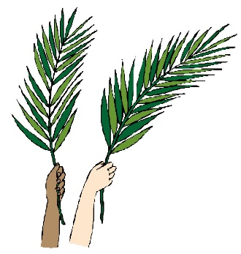
VI. Scientific Inquiry C. PHYSICAL SCIENCE 1. Demonstrates knowledge related to physical science Benchmark a. Explores and investigates objects that require positioning and movement through play (e.g., gears, marble chutes, screws in a toy workbench) | In our manipulatives center various gears have been added for the children to explore their movement as they connect them.  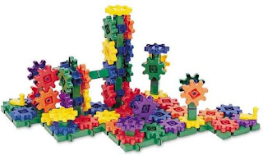 | Point out and discuss with your child various items around your home and surroundings that use gears, such as clocks and cars.

