STANDARDS | ACTIVITY | HOME EXTENSION
I. Physical Development B. MOTOR DEVELOPMENT c. Fine Motor Development  2. Increasingly coordinates hand and eye movements to perform a variety of actions with increasing precision  Benchmark a. Uses hand-eye coordination to manipulate objects and materials (e.g., completing large-piece puzzles or threading beads with large holes, begins to use scissors) | This week we will be talking a lot about Jesus’ miracles with fish. The children will each get to create their own fish bead craft- The children will create a fish by stringing beads on a pipe cleaner folding the ends over on the pipe cleaner (to keep the beads from falling off).  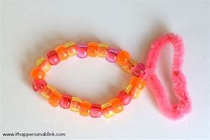 | While taking your child fishing this weekend or over a plate of fish sticks have your child recall the story of Jesus and the Fisherman.
I. Physical Development B. MOTOR DEVELOPMENT b. Gross Motor Perception (Sensorimotor) 1. Uses perceptual information to guide motions and interactions with objects and other people Benchmark a. Begins to act and move with purpose and recognizes differences in direction, distance, and location | Loaves and Fishes Toss Game- We are going to print out, laminate, and cut loaves of bread and fish, attach a clothes pin to each for weight. We will then have a basket and let the children take turns and try and toss the loaves and fishes into the basket. | At home create your own toss game using whatever is around the house. A bowl, basket or bucket, balls, stuffed animals, and everyone take turns trying to throw them in.  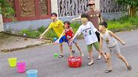
II. Approaches to Learning F. ENGINEERING AND TECHNOLOGY 1. Shows interest and understanding of how simple tools and machines assist with solving problems or creating objects and structures Benchmark b. Explores and identifies simple machines through play (e.g., ramps, gears, wheels, pulleys, and levers) | In our manipulatives center we added diagrams to show ramps made of magnetiles to encourage the children to investigate objects that require positioning and movement and for understanding simple machines  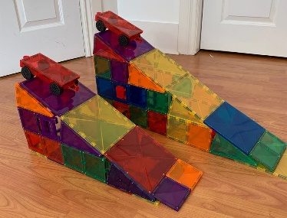 | When out with your child this week point out different times ramps are being used and why, like a wheelchair ramp.

