STANDARDS | ACTIVITY | HOME EXTENSION
VI. Scientific Inquiry A. SCIENTIFIC INQUIRY THROUGH EXPLORATION AND DISCOVERY 3. Uses understanding of causal relationships to act on social and physical environments Benchmark a. Makes simple predictions and reflects on what caused something to happen Benchmark b. Participates in and discusses simple experiments | This week we will start talking about Jesus’ miracles, His first miracle is turning water into wine. We will be turning our own water into wine by having a jar of water, with food coloring added to a piece of paper towel attached to the lid. The children will see ordinary water, but when we shake the jar, it will change color, looking like wine. | This week share a glass of grape juice with your child and discuss the things that have been miracles in your life.  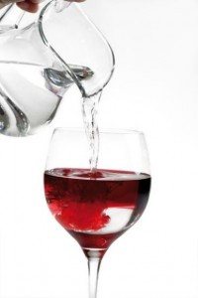
I. Physical Development B. MOTOR DEVELOPMENT b. Gross Motor Perception (Sensorimotor)1. Uses perceptual information to guide motions and interactions with objects and other people Benchmark a. Begins to act and move with purpose and recognizes differences in direction, distance and location Benchmark b. Demonstrates awareness of own body in relation to others | To celebrate Jesus turning water into wine the children will get to have a water relay race. Outside the children will be placed in 2-3 teams. One person from each team will fill their cup, run to the end, and dump it into a big bucket, run back to their team and pass on the cup to another teammate. The goal is to fill the bucket. | Hold your own water relay race with the whole family. Maybe invite the neighborhood kids to join in too.  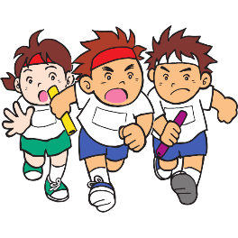
VI. Scientific Inquiry F. ENGINEERING AND TECHNOLOGY 1. Shows interest and understanding of how simple tools and machines assist with solving problems or creating objects and structures Benchmark b. Explores and identifies simple machines through play (e.g., ramps, gears, wheels, pulleys, and levers) | While discussing Jesus Healing the Paralytic man and how the man’s friends could have used a pulley to lower him down to Jesus, we will create a pulley out of 2 paper towel tubes with a straw as the crank and dowel and a spool of ribbon as the pulley and a ‘bed’ out of a cup for the paralytic man to be lowered down. | When out with your children this week point out different objects that use pulleys, such as an elevator or a car.

