Peek at Our Week
Standard Focus | Activity | Home Extension Activity
IV. LANGUAGE AND LITERACY  ALPHABET AND PRINT KNOWLEDGE  IV. F. 3. c. Names most letters  IV. F. 3. d. Recognizes some letter sounds | 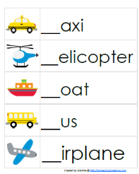  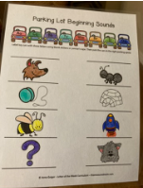  Beginning Sounds of Words-Matching letters to the beginning sounds of words | Florida Office of Early Learning:  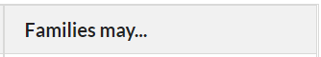  - Teach children to match the letters in their names with the sounds in their names.
V. MATHEMATICAL THINKING  E. ENVIRONMENT  PATTERNS  V. C. 2. Duplicates a simple AB pattern using different objects  V. C. 3. Recognizes the unit of repeat of a more complex pattern and extends the pattern (e.g., ABB or ABC) | Pattern Practice with ABAB AABAAB, BBABBA, and ABCABC patterns  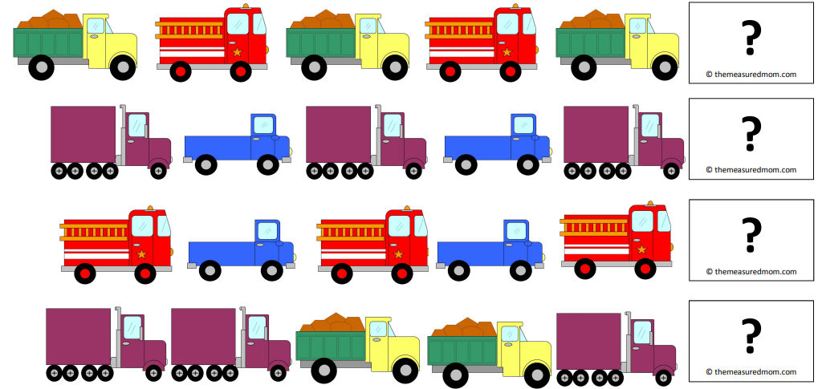 | Florida Office of Early Learning-VROOM  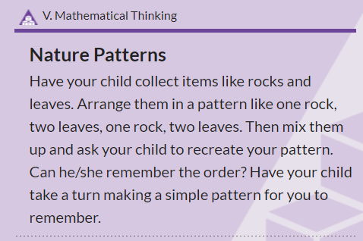
FAITH FORMATION  Ask for and listens to Bible stories. | 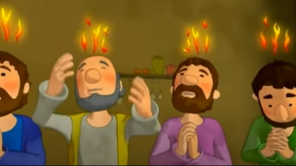  During this time of Easter Season, we are learning about the Early Church after Jesus ascended into Heaven. This week we will be reading a hearing: Acts 2: 1-11, which tells how Jesus’ disciples were filled with the Holy Spirit.  https://www.youtube.com/watch?v=IqG_lvZhU-A&t=3s | The Holy Spirit Comes  A KID-SIZED HOLY SPIRIT: CHILDREN TEND TO BE RECEPTIVE TO LEARNING ABOUT WHAT CAN BE THE MOST MYSTERIOUS PERSON IN THE HOLY TRINITY  https://occatholic.com/a-kid-sized-holy-spirit/

Parent Resources:
Other News: Starting this Friday, we will have Show-N-Tell. The students may bring something to school to show the class, but this item will need to stay in their cubby, except during our sharing time. Your child may want to bring a small toy or book that is special, and they may tell us about why it is special for them. We will have Show-N-Tell each Friday, until Friday, May 20, 2022.

