Peek at Our Week
Standard Focus | Activity | Home Extension Activity
IV. LANGUAGE AND LITERACY  F. EMERGENT READING  3. Shows alphabetic and print knowledge  IV. F. 3. b. Recognizes almost all letters when named (e.g., when shown a group of letters, can accurately identify, verbally or nonverbally, the letter that is named)  IV. F. 3. d. Recognizes some letter sounds (e.g., when shown a group of letters, can accurately identify, verbally or nonverbally, the letter of the sound given) | 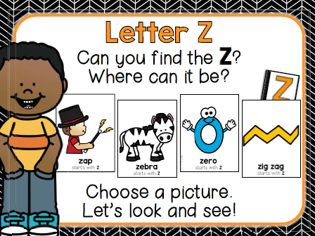  Our letter this week is “Zz” | LETTER Zz Activities at home  Zoo Animals Guessing Game  What Am I? Ask your child to take turns with you acting out animals that are found at the zoo. As each animal is acted out, discuss the beginning sound of the animal’s name (example: Tiger starts with /T/ sound).  Zigzag  Talk about walking in a zigzag, then practice walking that way. It will help if you place masking tape on the floor in a zigzag pattern for the children to walk on.  Have your child cut zigzag lines.
VI: SCIENTIFIC INQUIRY  E. ENVIRONMENT  1. Demonstrates awareness of relationship to people, objects and living/non-living things in their environment  VI. E. 1. b. Participates in daily routines demonstrating basic conservation strategies (e.g., conserving water when washing hands or brushing teeth) | 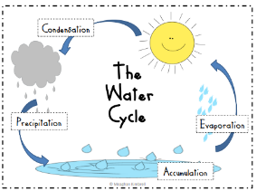  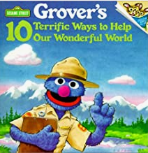  Learning about the  Water Cycle | EPA: Water Sense for Kids  https://www.epa.gov/watersense/watersense-kids  Simple Ways to Save Water  Turn off the Tap!  Just by turning off the tap while you brush your teeth in the morning and before bedtime, you can save as much as 4 to 8 gallons of water! That could add up to more than 200 gallons a month, enough to fill a huge fish tank that holds 6 small sharks.
V. MATHEMATICAL THINKING  V. MATHEMATICAL THINKING  A. NUMBER SENSE  V. A. 6. Uses counting and matching strategies to find which is more, less than or equal to 10 | 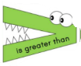 | Florida Office of Early Learning:  Go on a nature walk with your child and collect small objects that can be used to create and compare two sets, and to determine if the sets are equal (e.g., acorns, pine cones, small sticks and rocks).

Parent Resources:
More than, less than, equal to practice at home
ideas: https://www.themeasuredmom.com/less-than-greater-than-math-activity-using-toys/
Other News:
Thank you for all who shared plastic eggs, egg treats, and food/drinks to make our Easter egg hunt and party a success! Thank you also to the “Easter Bunnies” who helped hide the eggs!! Your help was much appreciated!

