Peek at Our Week
Standard Focus | Activity | Home Extension Activity
- Uses imagination and creativity to express self with intention using a variety of open-ended, process-oriented and diverse art materials | Painting with Cars  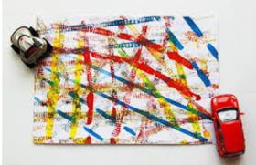 | This activity can easily be done at home. Collect a few cars, remember to count them. Run the car through some washable paint and then drive it on the paper. When you are done, you can set up a car wash in a small bin with some soap and water.
- Recognizes and names typical shapes (circle, square, triangle)  - Describes familiar people and objects in the environment | Discovering shapes on the playground  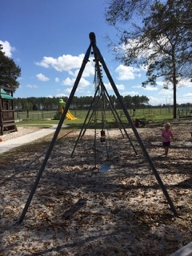 | Take a walk around your house or neighborhood and hunt for shapes. Take pictures of the shapes to share with other family members.
- Identifies basic physical characteristics (e.g., landmarks or land features)  - Increasingly coordinates hand and eye movements to perform a variety of actions with increasing precision  - Coordinates the use of arms, hands, fingers to accomplish tasks with hand-eye coordination when participating in routines, play and activities (e.g., painting at an easel, placing simple pieces of puzzle, folding paper) | Shape Clip Cards  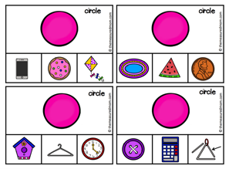 | Cut over different shapes. Show your child a shape and ask them to find an object or picture with that shape.
Parent Resources: Focus for the week is bikes and motorcycles along with circles, cubes, squares and rectangles.

