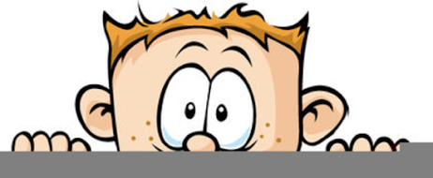

Peek at Our Week
Standard Focus | Activity | Home Extension Activity
- Counts and identifies the number sequence “1 to 10” | 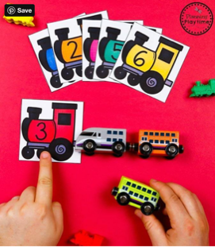  Making trains – Number recognition | Have your child count whenever possible! They can count the number of crackers they are having for snack, the number of socks in the laundry, the number of books on the shelf. You could write numbers on index card and have your child park that many cars on the card or put that many blocks on the card. The possibilities are endless!
- Recognizes and names typical shapes (circle, square, triangle)  - Matches a wider variety of shapes and orientations | Sponge Paint Train  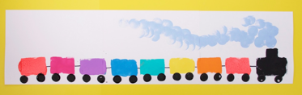 | Let your child make a train at home. Use the attached shapes and some glue and sit back and see what they create. Talk about the shapes they are using; how do they look the same and different.
- Recognizes and names typical shapes (circle, square, triangle) | Which Shape Does Not Belong Game  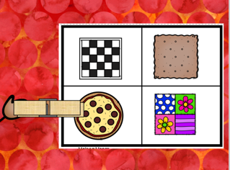 | Noticing the differences between objects is an important skill. During your normal routine start to point out differences such as Dad’s car has four doors and Mom’s has two. Or ask your child what is different between the two objects. Also put out three or four objects making sure that one does not belong and ask your child to tell you which one is wrong and why. Don’t let them just point at the object.
Parent Resources: Focus for the weeks is trains along with circles, cubes, squares and rectangles.

